|  |  |
| --- | --- |
| A picture of a winding road and trees  final website report-2022  http://hasanalhwietat.com/ | Abstract  I have recently joined a big company in the region that provides web solutions to startup e-commerce companies.  Hasan Alhwietat  Website |

Contents

Introduction: 2

Main idea to the website: 2

1- Identify the purpose and types of DNS, including explanations on how domain names are organized and managed. 2

2- Explain the purpose and relationships between communication protocols, server hardware, operating systems and web server software with regards to designing, publishing and accessing a website. 4

3- Discuss the capabilities and relationships between front-end and back-end website technologies and explain how these relate to presentation and application layers. 6

4- Discuss the differences between online website creation tools and custom-built sites with regards to design flexibility, performance, functionality, User Experience (UX) and User Interface (UI). 7

5- Create a design document for a branded, multipage website supported with medium fidelity wireframes and a full set of client and user requirements. 8

1-Site Map: 8

2-Wireframes: 8

3-Design Elements: 12

6- Use your design document with appropriate principles, standards and guidelines to produce a branded, multipage website supported with realistic content. 20

7- Create a suitable Test Plan identifying key performance area and use it to review the functionality and performance of your website. 26

8- Evaluate the impact of common web development technologies and frameworks with regards to website design, functionality and management. 26

9- Review the influence of search engines on website performance and provide evidence-based support for improving a site’s index value and rank through search. 28

10- Evaluate a range of tools and techniques available to design and develop a custom-built website. 30

11- Compare and contrast the multipage website created to the design document. 32

12- Evaluate the Quality Assurance (QA) process and review how it was implemented during your design and development stages. 33

13- Justify the tools and techniques chosen to realize a custom built. 34

14- Critically evaluate the design and development process against your design document and analyse any technical challenges. 34

15- Critically evaluate the results of your Test Plan and include a review of the overall success of your multipage website; use this evaluation to explain any areas of success and provide justified recommendations for areas that require improvement. 35

Domain and Hosting steps: 35

Publish you website: 45

# Introduction:

### Main idea to the website:

A website specialized in selling three types, namely books, glasses and watches. It displays product images, specifications and other things. When entering the site, the site asks the user: Do you want to create an account or do you have an account or just want to watch. Any option that the user chooses, the site sends it to the page he wants, but when you want to buy a specific thing,(The site sends you to the option to create an account if you do not have an account with the site) you are asked to enter your email, your full name and your phone number, and the money will be obtained upon receiving the product.

# 1- Identify the purpose and types of DNS, including explanations on how domain names are organized and managed.

-DNS server: It is a system of records of domain names and IP addresses that allows browsers to find the correct address that corresponds to the URL of the hostname entered into it. (DNS, 2021)

How does the DNS work? (DNS, 2021)

1- Request location information: When you type the domain name into the browser, the computer will look for the IP address associated with the DNS cache. If it exists locally, the site will be displayed. If it does not exist, a DNS query will be made to retrieve the information.

2- Contact the Recursive DNS Servers: Recursive DNS servers are used by many ISPs The domain name is in the cache The domain will be stored so the query will finish and the location will be displayed.

3- Query the Authoritative DNS Servers: If the recursive DNS servers do not contain information in the cache. Other servers will be searched, and then the servers will be queried. The search will continue until the domain name is found and stored in the records.

4- Access the DNS Record: Recursive DNS server when the query occurs on the server, the domain name is stored in the cache. If the domain name is requested again, the server will have an answer. When time passes, the records will be updated.

5- The final DNS Step: The recursive DNS server reads the IP address from the cache and passes it to the browser from the log The DNS.

**-URL (Uniform Resource Locator): it is a unique identifier is used to identify the location of a resource on the Internet. Also referred to as a web address. URLs are made up of multiple parts the protocol and the domain name that tell the web browser how and where to retrieve the resource. End-users use URLs by typing them directly into the browser's address bar or by clicking a hyperlink in a web page, bookmark list, email, or other application.**

A -Type DNS: (DNS, 2021)

1. Recursive resolvers: It is the first stop in a Domain Name System query. The iterative resolver acts as an intermediary between the client and the DNS name server. After receiving a DNS query from a web client, the iterative resolver will either respond with the cached data, or send a request to a root name server, followed by another request to the Top-level domain name server, and then a final request to an authoritative name server.

Responsible for responding to inquiries from customers.

2. Root:

The root name server (also called a DNS root server or root server for short) is responsible for the basic functions when it comes to translating domain names into IP addresses: it answers client requests in the domain name system root zone (the root zone tags the largest layer in the DNS namespace). Here, the root name server does not perform the name resolution itself and instead informs the requesting client of another name server (DNS server) from which it can get more information regarding the requested IP address.

3. TLD (top-level domain):

A TLD name server keeps information for all domain names that share a common domain extension, such as .com, .net, or whatever comes after the last dot in a URL. For example, a .com TLD name server contains information for every website that ends in ".com". If the user is searching for google.com, after receiving a response from a root name server, the iterative resolver will then send a query to the .com TLD name server, which will respond by pointing to the authoritative name server (see below) for that domain.

1. Authoritative:

It is a name server that gives answers in response to questions about names in a region. Only an authorized name server returns answers to queries about domain names specifically configured by the administrator. Name servers can also be configured to give authoritative answers to queries in some zones, while acting as a caching name server for all other zones. When the recursive resolver receives a response from the TLD name server and that response will direct the resolver to an authoritative name server.

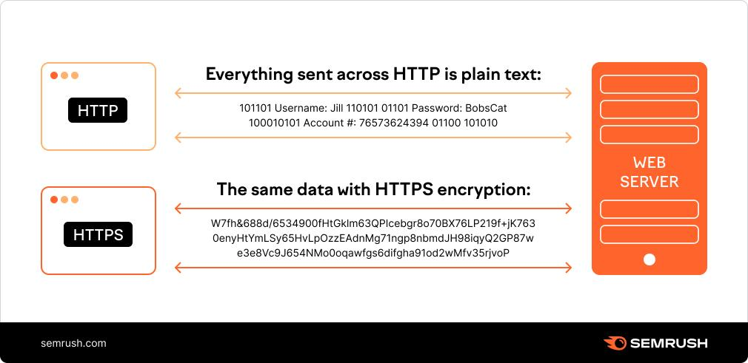

https://www.google.com/index.html

Protocol

Second-level domain name

File name

Top-level domain name

Host Computer Name

# 2- Explain the purpose and relationships between communication protocols, server hardware, operating systems and web server software with regards to designing, publishing and accessing a website.

(communication protocal, 2022)

* Communication protocols:

1-HTTP: (Hypertext Transfer Protocol) as a request-response protocol, HTTP provides users with a way to interact with web resources such as HTML files by sending hypertext messages between clients and servers. HTTP clients generally use Transmission Control Protocol (TCP/IP) connections to communicate with servers. The HTTP protocol uses port 80.

2-HTTPS: (Hypertext Transfer Protocol Secure) it is a secure protocol that encrypts the data that is sent to websites. It encrypts the data by exchanging keys with the client and the website. Thus, encryption occurs, so that if an interception occurs and the information is stolen, the decryption can only be done if he possesses the keys from the owner or client. The HTTP protocol uses port 443. An encryption protocol is called (TLS).

3-TCP/IP: TCP (Transmission Control Protocol) a standard that defines how to create and maintain a network conversation through which applications can exchange data. TCP works with the Internet Protocol (IP), which defines how computers send data packets to each other. TCP and IP together are the basic rules that define the Internet. Used to transmit data all use TCP Protocol. For example FTP, SSH, IMAP, POP, SMTP.

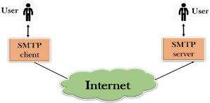4-FTP: File Transfer Protocol refers to a process that involves transferring files between devices over a network. The process works when one party allows another party to send or receive files over the Internet.

5-SMTP: (Simple Mail Transfer Protocol) it is an application used by mail servers to send, receive and/or relay outgoing mail between email senders and recipients SMTP runs on TCP/IP and listens on port 25.

6-POP: (Post Office Protocol) is a network server through which client-based email programs are connected to access a user's email on a central server.

7-UDP: (User Datagram Protocol) it is a communication protocol used over the Internet for particularly time-sensitive transmissions such as video playback or DNS lookups.

8-DHCP: (Dynamic Host Configuration Protocol) It is a network management protocol used to automate the process of configuring devices on IP networks. A dynamic DHCP server assigns an IP address for each device on the network so that it can communicate with another device on another network.

* Web Server:

1-Hardware: it is a computer that stores webserver software and files related to a website, (for example, HTML documents, images, JavaScript files). The web server connects to the Internet and supports the exchange of physical data with other devices connected to the web.

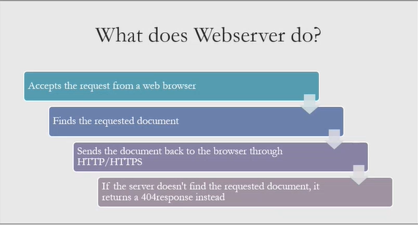2-Software: The web server software is accessed through the domain names of the websites and ensures that the content of the website is delivered to the user who requests it. The software side also consists of several components, with at least an HTTP server. The HTTP server can understand HTTP and URLs.

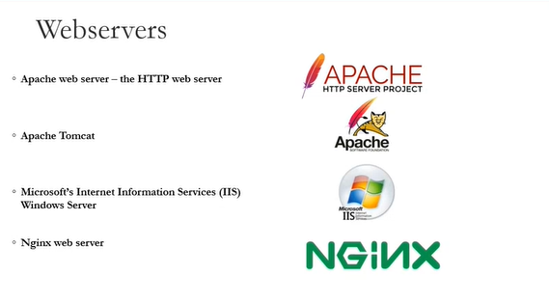

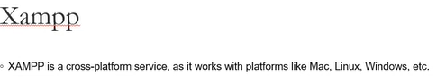

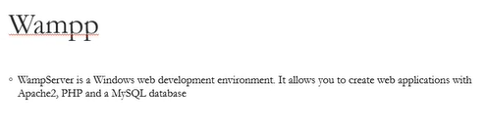

* Operating systems:

It is an interface between a computer and a computer user. An operating system is a software that performs all the basic tasks such as managing files, managing memory, managing processes, processing inputs and outputs, and controlling peripheral devices such as drives and printers.

Examples: Linux, windows.

Features of Operating system:

1- Protected and Supervisor mode.

2. Allows access to disk, file systems, device drivers, and network security.

3- Implementation of the program.

4- Memory management virtual memory multitasking.

5- Handling I/O operations.

6- Error detection and handling.

7- Allocate resources.

8- Protection of information and resources.

# 3- Discuss the capabilities and relationships between front-end and back-end website technologies and explain how these relate to presentation and application layers.

(application layer, 2022)

1- The front-end is the user interface/client and code/tools related to it. User interface code and tools are CSS, HTML, and JavaScript and the many tools and frameworks that work with these technologies and this will be how the User/Human will interact with the application.

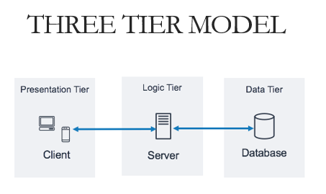2- The back end is the server-side and the related code/tools. The backend/server will communicate over the Internet in response to requests via a protocol called “HTTP” which facilitates requests/responses in the form of “packets” across a network or networks. The back end will contain some Boolean code (PHP, Python, Java, etc.) that will tell the server what to do.

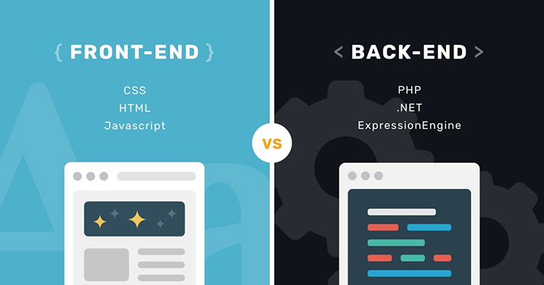

* LAYERS:

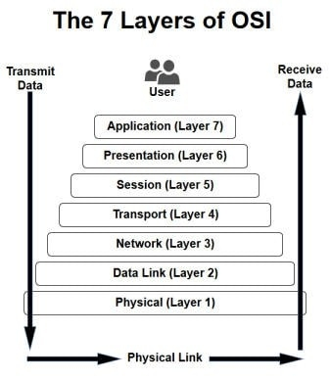

1- Presentation layer: (front-end)

It is the 6 layer of the OSI model. It is a graphical user interface (GUI) and communication layer of the application that can be accessed through a web browser that displays useful information to the end-user and the user might fill in his information. This layer is created using (HTML, CSS, and JavaScript).

2- Application layer: (back-end) this layer sits between the presentation layer and the data layer.

It is the 7 layer of the OSI model. It is known as the logical layer or the middle layer, which is the heart of the application and is created using (Python, C++, Perl, PHP or Ruby, Java, C #, etc.) and the application layer is the highest level of open systems. Also in this layer, information collected from the presentation layer is sometimes processed against other information from the data layer using business logic. This layer can delete and modify data in the data layer. The application layer communicates with the data layer using API calls.

3- Data layer: (back-end)

It is the 2 layer of the OSI model. The data layer is a data storage system or database that contains all the data that is generated by visitors who interact with a website. The data layer is called the data access layer or the database layer. It is created using (MySQL, Oracle, PostgreSQL, MongoDB, Microsoft SQLServer, etc.) and the application layer accesses the data through API calls.

# 4- Discuss the differences between online website creation tools and custom-built sites with regards to design flexibility, performance, functionality, User Experience (UX) and User Interface (UI).

|  |  |  |
| --- | --- | --- |
| Compare | Tools | Custom-built |
| Identification | They are templates used to create websites that are easy and fast to use that allow you to develop your website without the need to learn how to program and do not need special skills and do not take time to create. (tools, 2021) | They are sites that are designed by writing the code and this is done from the beginning and requires a number of skilled and reliable people or one person to create the site that represents brand and it takes a lot of time to create. (custom built, 2021) |
| Design flexibility | It is easy to design and provides many features. When you want to add images, text, or addresses, you drag and drop the element to the place you want. | Tailored sites are flexible and can grow and can be developed in the future and it is easy to add new features to the site. And suitable for needs. |
| Performance | These sites that were created are usually heavy and slow to load and affect the performance of the site’s search engine optimization and make it difficult for Google to read. | The site it will be distinctive and of high quality and will be more efficient in the performance of the site because it will contain only the code and therefore it will work correctly without errors. |
| Functionality | There is a limitation on what you want to do such as changing the templates or the look and the functions are limited. | There are no restrictions on graphics nor functionality. It is easy to update sites on demand, and can also add what you want. |
| User experience | It can't be very user friendly because you will be restricted in the way you want to navigate between pages and it will negatively affect the user experience and be frustrating. | Increase the effectiveness of the user experience, very convenient for users and easy to use. |
| User interface | Destination is similar to other sites because it has limited templates and layout, as well as the nature of the devices in which it works, it may require additional costs to operate. | A distinctive and different interface from other sites and helps to improve search engines and thus enhances its visibility to people and works on all devices and is available at any time. |

# 5- Create a design document for a branded, multipage website supported with medium fidelity wireframes and a full set of client and user requirements.

Design Document: (Design Document, 2021)

A collection of documents and resources that cover all aspects of your product design. Documentation should include information about users, product features and project deadlines. All essential implementation details; and design decisions that your team and stakeholders have agreed to.

## 1-Site Map:

A website planner that helps search engines find, crawl, and index website content. Sitemaps also tell search engines which pages are the most important on a site.

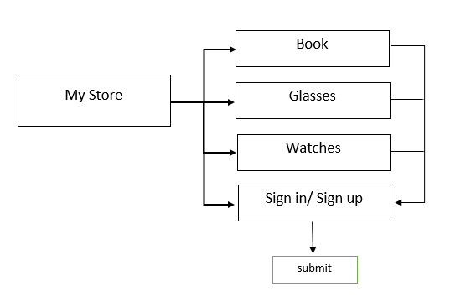

## 2-Wireframes:

It is a method of designing a site service at the structural level. The wireframe is commonly used to plan content and functionality on a page that takes into account user needs and user journeys. Frames are used early in the development process to create the basic structure of the page before adding the visual design and content.

2.1- Homepage:

The main page of the site through which it is possible to navigate between other pages that the user can see and other information about the site and how to communicate with the company and social media.

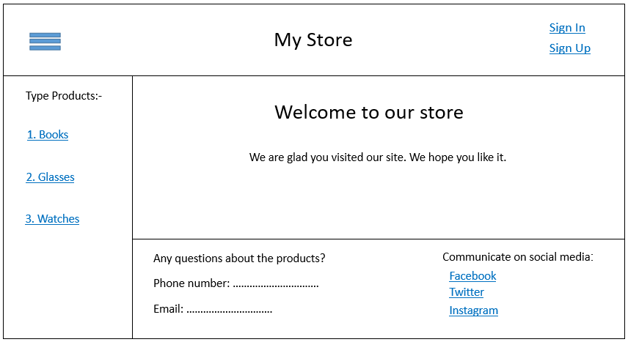

2.2-Books page:

Books page The user can read the information about the products displayed on the site, and he can also buy products and navigate to other products.

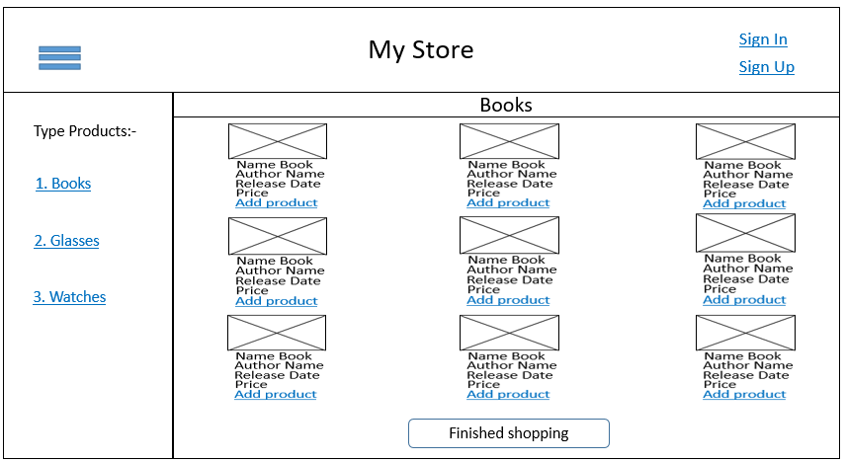

2.3-Glasses page:

Glasses page The user can read the information about the products displayed on the site, and he can also buy products and navigate to other products.

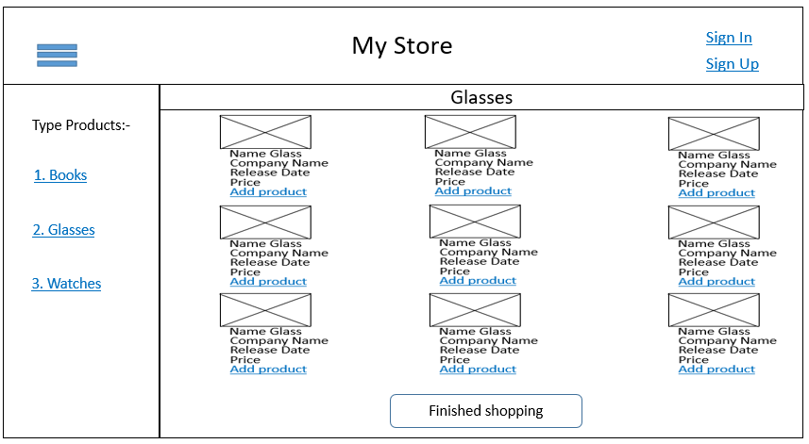

2.4-Watches page:

Watches page the user can read the information about the products displayed on the site, and he can also buy products and navigate to other products.

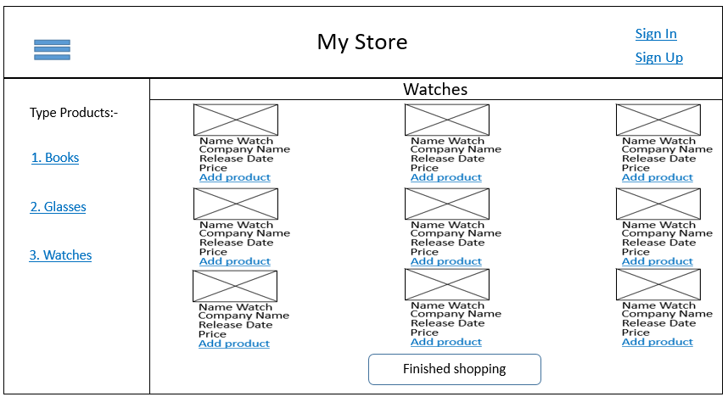

2.5-Sign In page:

Login page The user can log in to his account if he has an account and if he cannot create a new account.

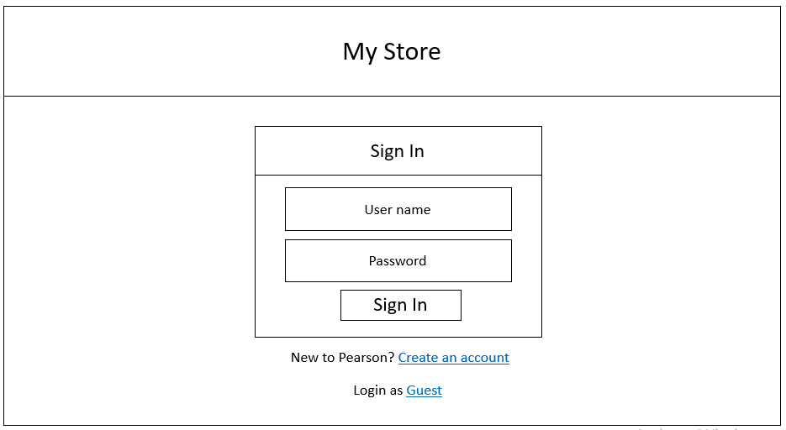

2.6-Sign Up page:

The registration page is for the user who does not have an account on the site, and he can also go to the login page if he has an account.

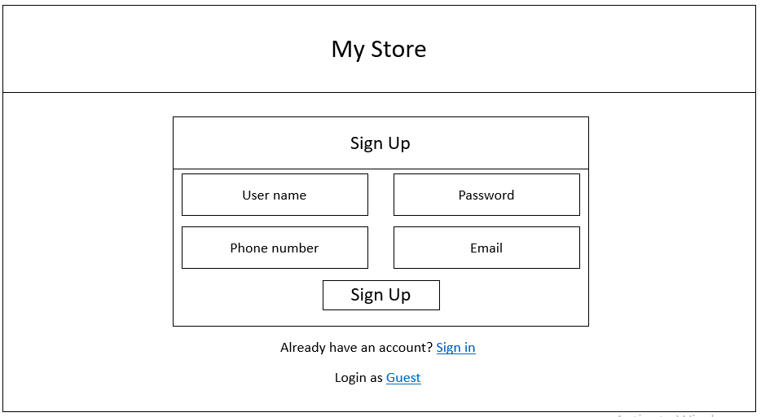

2.7-Submit page:

The submission page displays the total price of the products to the user, and after the user agrees to this, he makes a dispatch in order to order the products.

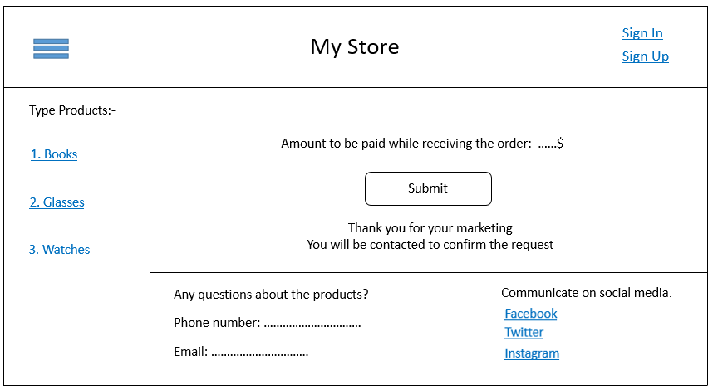

## 3-Design Elements:

Design elements influence how a work piece is perceived, implemented and used – and they are present in design regardless of skill, taste or style.

3.1- Main elements:

This part defines the common elements that will be presented for all pages.

|  |  |  |  |  |  |
| --- | --- | --- | --- | --- | --- |
| No. | Name | Place | Type | Description | Message |
| 1 | My Store | Top the page | Text | Name the website |  |
| 2 | Sign In  Sign Up  User name | Top of the page on the right | Link  Link  Text | Open the Sign Up page  Open the Sign In page  Name the user | Success |
| 3 | Type Products  Books  Glasses  Watches | Center of the page on the left | Text  Link  Link  Link | Open the books page  Open the glasses page  Open the watches page | Success |

3.2- Sign In Box:

The user can enter the user name and password to log in if he has an account. If he does not have an account, he can create an account. If he just wants to view the site without buying anything, he can click on a guest.



|  |  |  |  |  |  |
| --- | --- | --- | --- | --- | --- |
| No. | Name | Place | Type | Description | Message |
| 1 | User name | Sign in Box | Text Box | The username of user | Required |
| 2 | Password | Sign in Box | Text Box | The password of user | Required |
| 3 | Sign In | Sign in Box | Button | When the user enters the username and password and then clicks on the login button, the user is considered logged-in. The login button disappears and the welcome message appears instead. | User name/password not correct |
| 4 | Create an account | Down Sign in Box | Link | Open the Sign Up page | Success |
| 5 | Guest | Down Sign in Box | Link | Open the Home page | Success |
| 6 | My Store | Top the page | Text | Name the website |  |

3.3- Home Page:

The user can log in if he has an account or create an account if he does not have an account and he can go to the social networking page of the site or communicate by phone or mail for any inquiries and can go to products books, glasses and watches.



|  |  |  |  |  |  |
| --- | --- | --- | --- | --- | --- |
| No. | Name | Place | Type | Description | Message |
| 1 | My Store | Top the page | Text | Name the website |  |
| 2 | Sign In  Sign Up  User name | Top of the page on the right | Link  Link  Text | Open the Sign Up page  Open the Sign In page  Name the user | Success |
| 3 | Welcome to our store  ….. | Center of the page | Text | welcome phrase to the website |  |
| 4 | Type Products  Books  Glasses  Watches | Center of the page on the left | Text  Link  Link  Link | Open the books page  Open the glasses page  Open the watches page | Success |
| 5 | Any questions …  Phone number  Email | Down of the page | Text  Text Box  Text Box | For any inquiries, call the following number or email. | Required |
| 6 | Social media | Down of the page on the right | Text  3 Icons and link | To connect on social medi. | Success |

3.4 Sign Up page:

The user can create an account by entering the user name, password, phone number and email. If he has an account, he can press log in, and if he does not want, he can continue as a guest.



|  |  |  |  |  |  |
| --- | --- | --- | --- | --- | --- |
| No. | Name | Place | Type | Description | Message |
| 1 | User name | signup Box | Text Box | The username of user | Required |
| 2 | Password | signup Box | Text Box | The password of user | Required |
| 3 | Phone number | signup Box | Text Box | The phone number of user | Required |
| 4 | Email | signup Box | Text Box | The Email of user | Required |
| 5 | Sign Up | signup Box | Button | When the user enters the username and password and then clicks on the login button, the user is considered logged-in. The login button disappears and the welcome message appears instead. | User name/password not correct |
| 6 | Sign In | Down signup Box | Link | Open the Sign In page | Success |
| 7 | Guest | Down signup Box | Link | Open the Home page | Success |
| 8 | My Store | Top the page | Text | Name the website |  |

3.5 Books page:

The user can enter the login page, create an account, or add products to the cart, he can navigate to the glasses and watches page, and when he finishes shopping, he clicks to finish shopping.



|  |  |  |  |  |  |
| --- | --- | --- | --- | --- | --- |
| No. | Name | Place | Type | Description | Message |
| 1 | My Store | Top the page | Text | Name the website |  |
| 2 | Sign In  Sign Up  User name | Top of the page on the right | Link  Link  Text | Open the Sign Up page  Open the Sign In page  Name the user | Success |
| 3 | Images | Center of the page | images | Images to the products |  |
| 4 | Type Products  Books  Glasses  Watches | Center of the page on the left | Text  Link  Link  Link | Open the books page  Open the glasses page  Open the watches page | Success |
| 5 | Name book  Author name  Release Date  Add product | Center of the page | Text  Text  Text  link | Information on product.  The product is added to the cart. | Success |
| 6 | Finished shopping | Down of the page | Button | When the user has finished shopping, press finished shopping. | Success |
| 7 | Book | Down of the name the website | Text | Name to the product |  |

3.6 glasses page:

The user can enter the login page, create an account, or add products to the cart, and he can navigate to the Books and Watches page, and when he finishes shopping, he clicks to finish shopping.



|  |  |  |  |  |  |
| --- | --- | --- | --- | --- | --- |
| No. | Name | Place | Type | Description | Message |
| 1 | My Store | Top the page | Text | Name the website |  |
| 2 | Sign In  Sign Up  User name | Top of the page on the right | Link  Link  Text | Open the Sign Up page  Open the Sign In page  Name the user | Success |
| 3 | Images | Center of the page | images | Images to the products |  |
| 4 | Type Products  Books  Glasses  Watches | Center of the page on the left | Text  Link  Link  Link | Open the books page  Open the glasses page  Open the watches page | Success |
| 5 | Name glass  Company name  Release Date  Add product | Center of the page | Text  Text  Text  link | Information on product.  The product is added to the cart | Success |
| 6 | Finished shopping | Down of the page | Button | When the user has finished shopping, press finished shopping. | Success |
| 7 | Glasses | Down of the name the website | Text | Name to the product |  |

3.7 watches page:

The user can enter the login page, create an account, or add products to the cart, and he can navigate to the books and glasses page, and when he finishes shopping, he clicks to finish shopping.



|  |  |  |  |  |  |
| --- | --- | --- | --- | --- | --- |
| No. | Name | Place | Type | Description | Message |
| 1 | My Store | Top the page | Text | Name the website |  |
| 2 | Sign In  Sign Up  User name | Top of the page on the right | Link  Link  Text | Open the Sign Up page  Open the Sign In page  Name the user | Success |
| 3 | Images | Center of the page | images | Images to the products |  |
| 4 | Type Products  Books  Glasses  Watches | Center of the page on the left | Text  Link  Link  Link | Open the books page  Open the glasses page  Open the watches page | Success |
| 5 | Name watch  company name  Release Date  Add product | Center of the page | Text  Text  Text  link | Information on product.  The product is added to the cart | Success |
| 6 | Finished shopping | Down of the page | Button | When the user has finished shopping, press finished shopping. | Success |
| 7 | Watches | Down of the name the website | Text | Name to the product |  |

3.8 submit page:

The user can enter the login page or create an account to purchase the products that he added to the basket. He can also communicate via social media, by phone or email, and he can press send to confirm the request, and then the user will be contacted to confirm the request.



|  |  |  |  |  |  |
| --- | --- | --- | --- | --- | --- |
| No. | Name | Place | Type | Description | Message |
| 1 | My Store | Top the page | Text | Name the website |  |
| 2 | Sign In  Sign Up  User name | Top of the page on the right | Link  Link  Text | Open the Sign Up page  Open the Sign In page  Name the user | Success |
| 3 | Type Products  Books  Glasses  Watches | Center of the page on the left | Text  Link  Link  Link | Open the books page  Open the glasses page  Open the watches page | Success |
| 4 | Social media | Down of the page on the right | Text  3 Icons and link | To connect on social media. | Success |
| 5 | Any questions …  Phone number  Email | Down of the page | Text  Text Box  Text Box | For any inquiries, call the following number or email. | Required |
| 6 | order price | Center of the page | Text | The sum of the prices of the products that the user wants to buy |  |
| 7 | submit | Center of the page | Button | When you have finished shopping, press the word send | Success |
| 8 | Thank the user | Center of the page on the down submit | Text | Thank the user for visiting the site and purchasing the products |  |

# 6- Use your design document with appropriate principles, standards and guidelines to produce a branded, multipage website supported with realistic content.

**Principles, standards of website:** (principles website, 2021)

1- Purpose of the website: The website must meet the user's needs and make them satisfied with the performance and appearance of the website.

2- Simplicity: This method must be followed for the ease of use of the site by users, and one of the things that makes it easy is the colors. When choosing the appropriate colors, they help attract users to visit the site and make them feel happy, and the fonts. The site should have only three lines as a maximum, and the images should contain the site contains high-quality images and videos to create an impression of the site's quality and credibility.

3- Navigation: The site must contain what visitors are looking for and ease of navigation on the site to attract visitors because if the navigation is difficult, the user will give up and leave the site and go to another site.

4- Visual hierarchy: Arrange the elements on the site according to importance through images, colors and style, and make it clear to users the most important information on this site.

5- Content: The site should have a unique design and content that attracts visitors to the site, makes them happy, and spreads the site to their friends.

6- Grid-based layout: Grids help organize the design, maintain the content, and arrange the elements for a sense of balance and make the site more aesthetic.

7- Load time: The site should be fast and make visitors not wait. The loading of the site should not take two seconds or less, because if it takes a lot of time, visitors will leave the site.

8- Mobile-friendly: The site must be compatible with phones, laptops and other devices because visitors enter the sites with different devices.

**Guidelines and standards of website:** (guidelines, 2021)

1- Immediate Page Loading: Visitors should not wait for a long time to enter the site, so it must be fast.

2- Mobile-Friendly: Make sure that the site is suitable for phones, and a site that works on many devices is an ideal site.

3- Responsive designs: When the site is responsive, the user will feel satisfied, which is an essential part of the redesign.

4- Analyze conversion rate: A site with a good analysis is a great site because it defines the goals of the site. It will help the site’s development to know the number of visitors and user satisfaction.

5- SEO-Friendly: When designing your site, you must take into account the elements of search engine optimization, which helps you to keep your site at the top of the search. Using the XML sitemap.

6- Content Management System: Your site must have a design that attracts the user's attention and makes it unique from other sites.

7- Social Media Integration: Your page must interact with social networking sites, because when your page is searched for in social networking sites, it must contain information about your site to help bring visitors and log in through social media accounts.

8- Provide on-site Security: The site must maintain customer data and maintain its security by conducting some continuous security checks.

9- Search feature: Your site must have a search feature in order to facilitate the matter for the customer, and it must be clear and at the top of the page.

10- Impressive home page: The page must be beautiful, of high quality, and attract customers to the site.

1- Home page

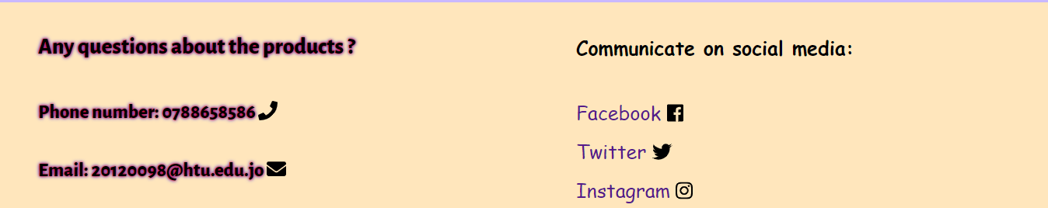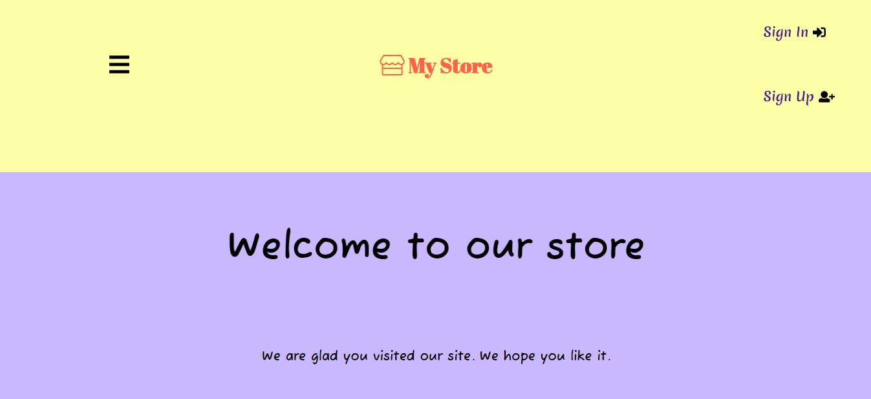

2- Sign in page: 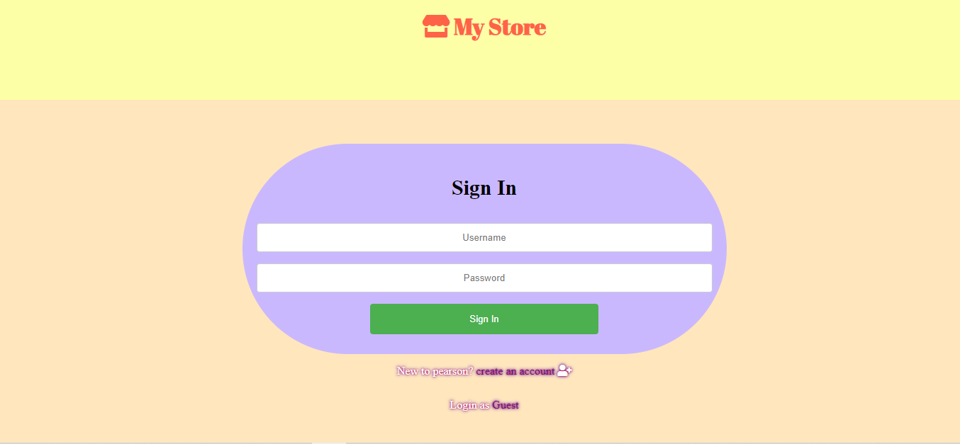

3- Sign up page:

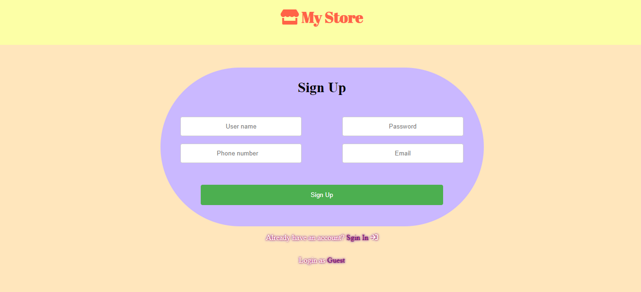

4- Books page:

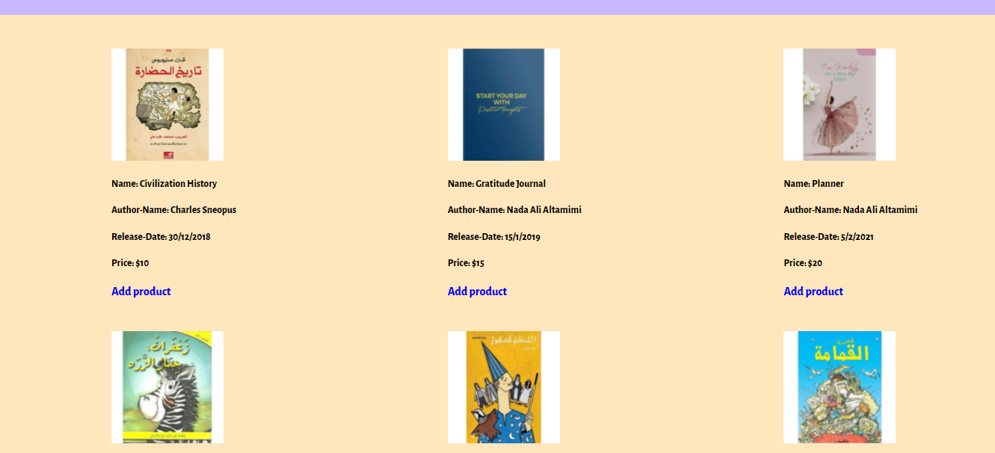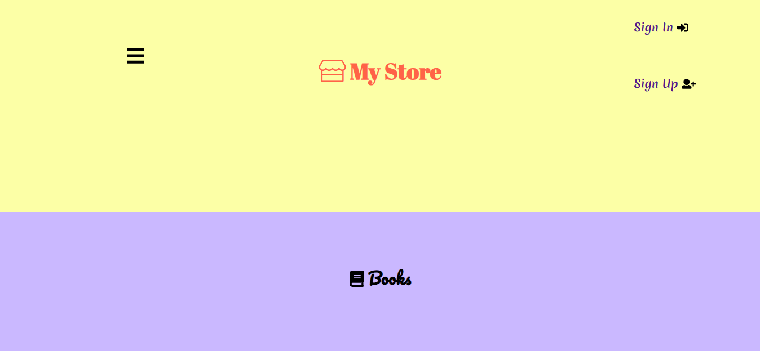

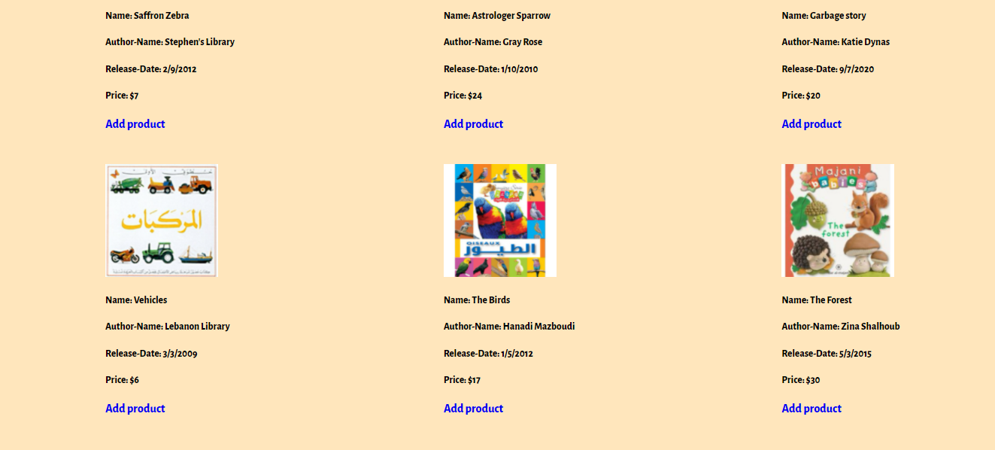



5- Glasses page:

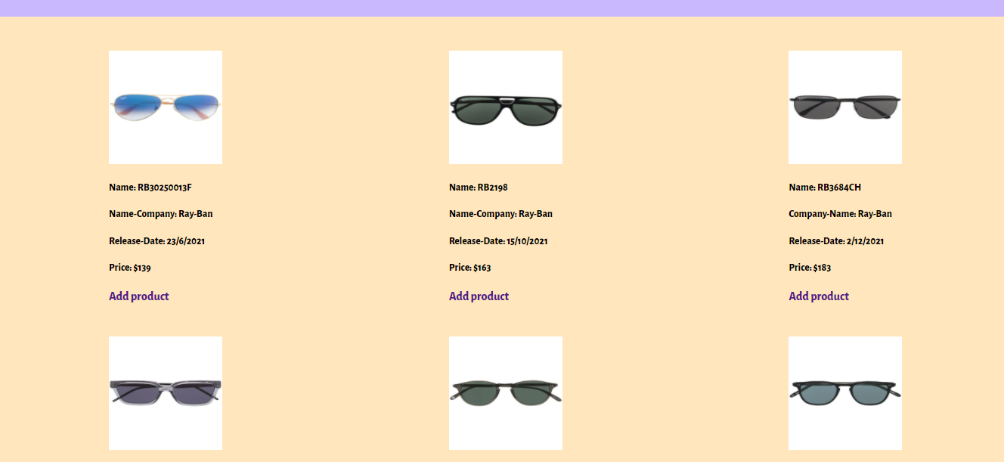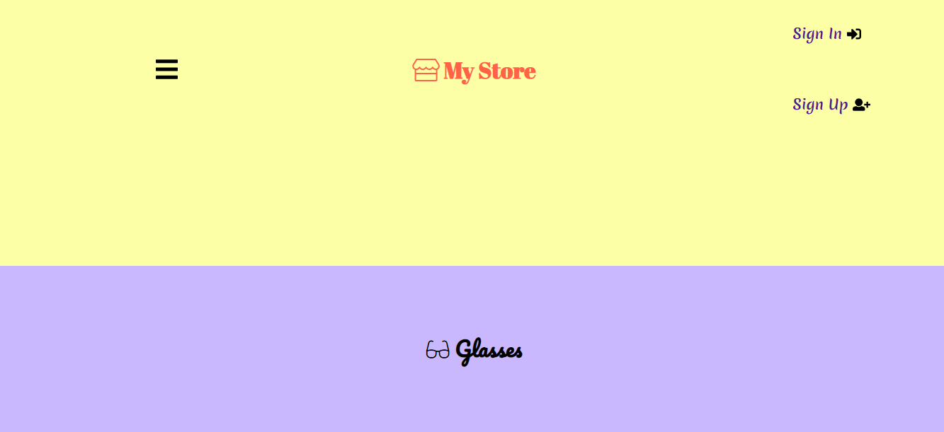

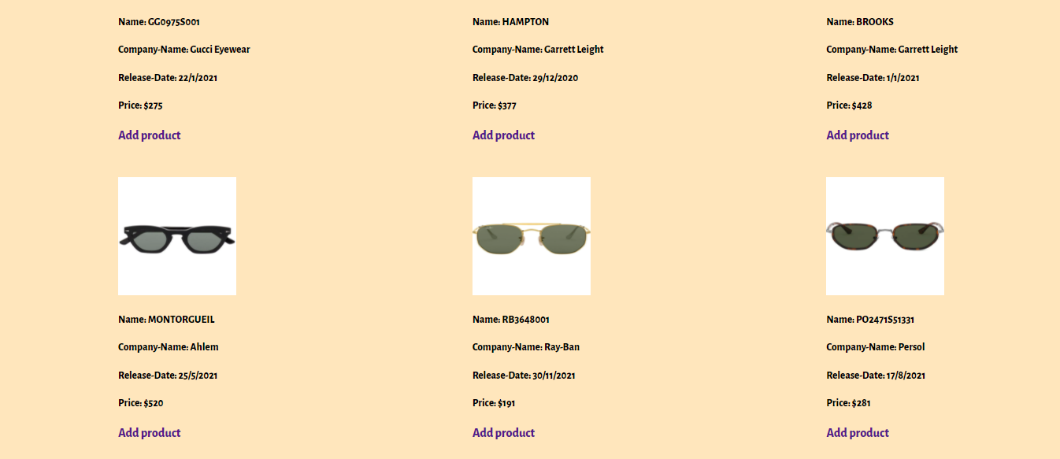



6- Watches page:

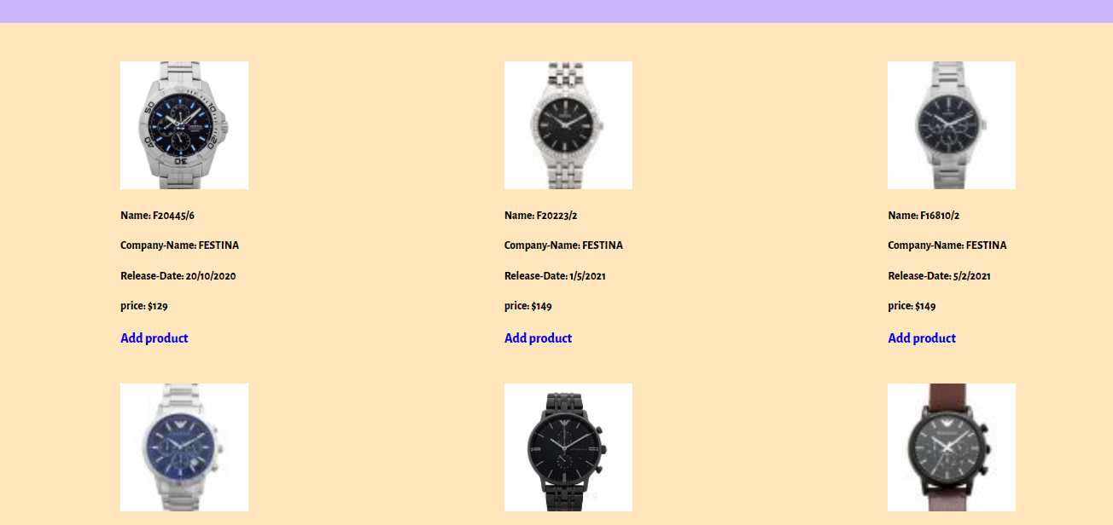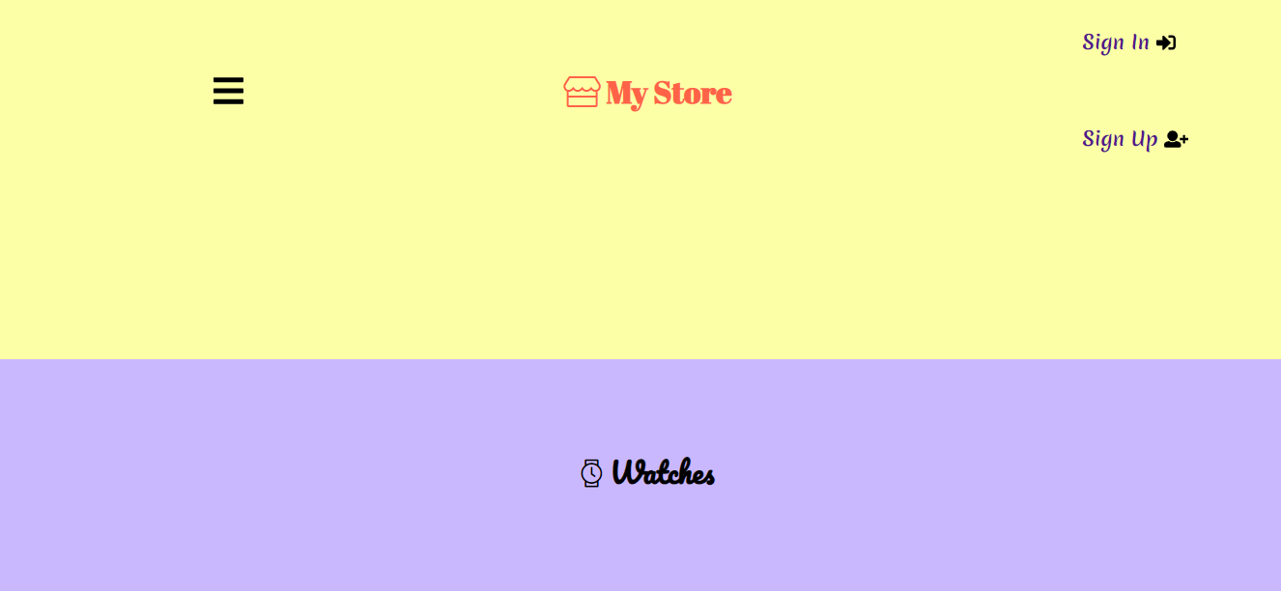

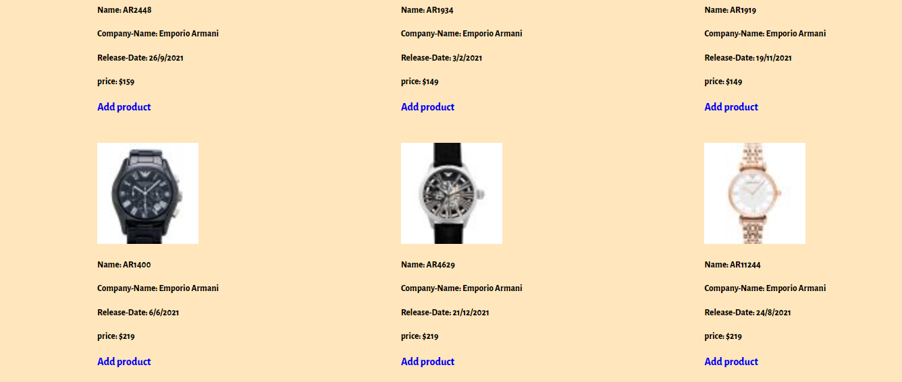



7- Submit page:

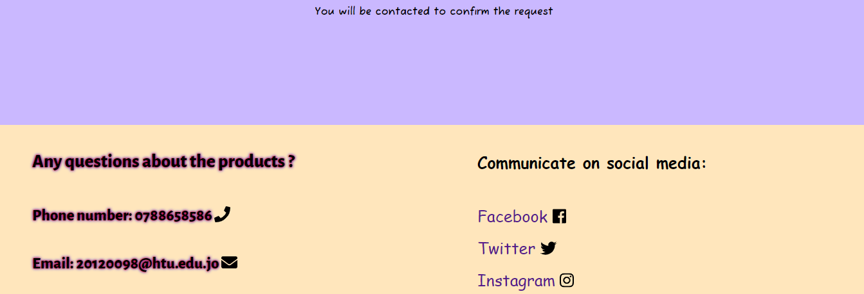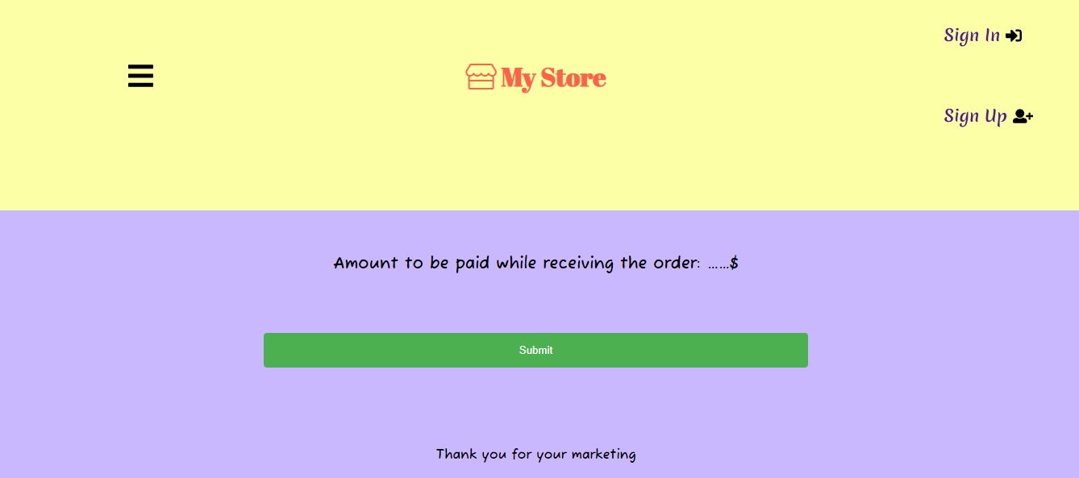

# 7- Create a suitable Test Plan identifying key performance area and use it to review the functionality and performance of your website.

Test Plan: A detailed document of the tested strategy, objectives, schedule, and resources required to conduct the test. The test plan helps verify the quality of the site and ensure that it is operating as intended. (Testplan, 2021)

|  |  |  |  |  |
| --- | --- | --- | --- | --- |
| Test Case Type | Description | Test Step | Expected Result | Status |
| Functionality | When we enter the sign up page and enter the username, it must be up to 20 characters long. | Input more than twenty characters. | The username will be rejected because it exceeds the required number of characters. | Pass |
| Security | Verify the password, its work, and its rules. | Create a new password in accordance with rules | The user’s password will be accepted if it adheres to the rules and required number of characters. | Pass |
| Usability | Ensure all links are working. | Click on all links on the site. | Links will take users to another web page according to the on-page URL. | Pass |
| Interface | Ensure all pages take styling. | Enter to all pages on the site | All pages will be styled appropriately. | Pass |
| Database | Ensure that the data is stored | Create a new user | All new user information will be stored in the database. | Pass |

# 8- Evaluate the impact of common web development technologies and frameworks with regards to website design, functionality and management.

**Framework:** It is a multi-layered architecture and a set of resources and tools for web development, files and folders containing code (such as HTML, CSS, and JavaScript) used to simplify the web development process and make it easier to create. (framework, 2021)

The goal of the framework is to provide a common structure so that programmers do not have to repeat the code from the beginning, and these codes allow programmers to reduce effort and save time.

For example: Bootstrap, Base, Susy, Kube, etc.

|  |  |
| --- | --- |
| **Framework** | |
| **Advantages** (framework, 2021) | 1- Facilitates and fastens the mock-up process.  2- Clean and tidy code.  3- Frameworks take care of browser compatibility.  4- Learn good practices.  5- Helpful in collaborative work.  6- Easy debugging process.  7. Improve code efficiency.  8- Easy to reuse the code.  9. Enhance security. |
| **Disadvantages** (framework, 2021) | 1- Mixed content and presentation.  2- Unused code leftover.  3- Slower learning curve.  4- You will learn frameworks, not programming.  5- Affect the speed and performance of websites.  6-Restriction. |

Web development techniques: They are many programming languages for producing websites and applications, and they are divided into front-end and back-end technologies. (web development, 2021)

Front-end technologies are HTML, CSS, and JavaScript.

The backend technologies are PHP, Python, and Java.

These techniques help to create a suitable website that attracts customers to the sites and they can browse their site on the URL like other sites.

Web development techniques help design a website that is characterized by the ability to control your site and show high quality to the front end, and you can modify it after completing its design, and it has many functions, ease of site management, high protection and high speed in opening the site.

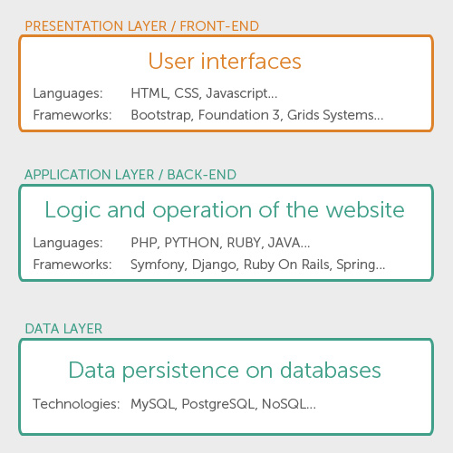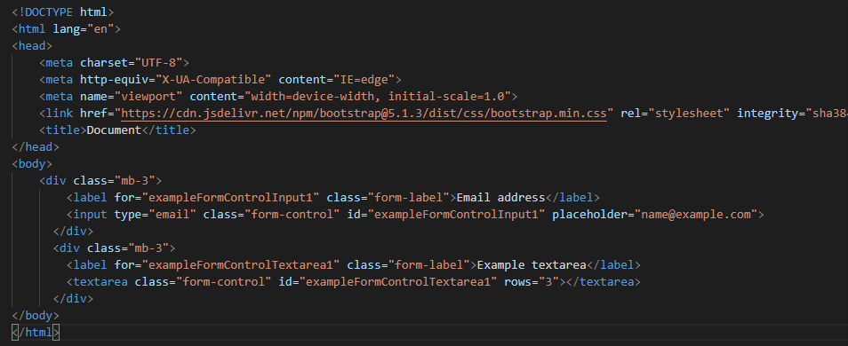Example on framework: (Bootstrap)

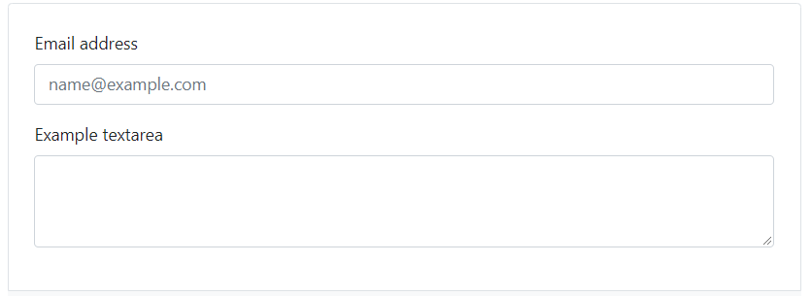

**Result**

Show the options you have chosen to develop the website:

Front-end chosen to develop the website are HTML, CSS, and JavaScript.

The back-end chosen to develop the website are PHP, MySQL.

# 9- Review the influence of search engines on website performance and provide evidence-based support for improving a site’s index value and rank through search.

Search engine optimization (SEO): It is a process to improve your site to increase its visibility when it is searched by customers or for services related to the site and search engines are like Google and others whenever the page appears better on search results and thus will attract customers to your site. (SEO, 2021)

Search engine optimization is important for websites because it helps with marketing and makes it easier for customers to find the websites they want. GSC is also one of the most important search engine optimization (SEO) tools that detect how well all pages rank, add maps to your site, identifies errors that need to be fixed and makes the site compatible with phones It shows whether your site has been hacked.

**How to set-up a Search Console:**

**1-** **Sign in to Search Console with your Google account and if you do not have one, create a new one.**

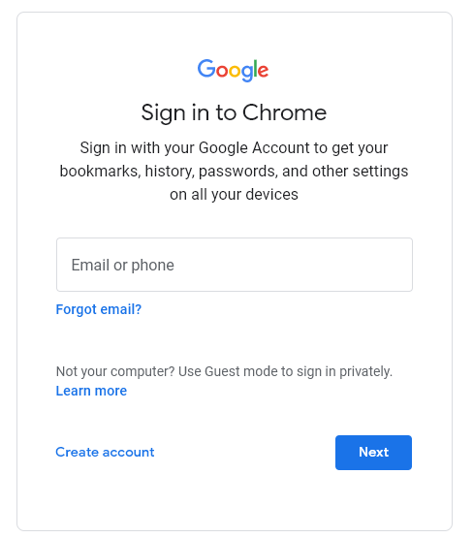

**2-** **Enter Your Website’s Domain or URL-Prefix to Add a Property.**



**3-** **Verify Your Website to implement Google Search Console and start gathering data, you need to verify that you own your site.**

**You choose this method, you need to upload the HTML file to the root folder of your website.**



Download the file provided by Google. (By clicking the download box shown in the image above.)

Access the root directory (aka public_html) of your site. Upload the file.

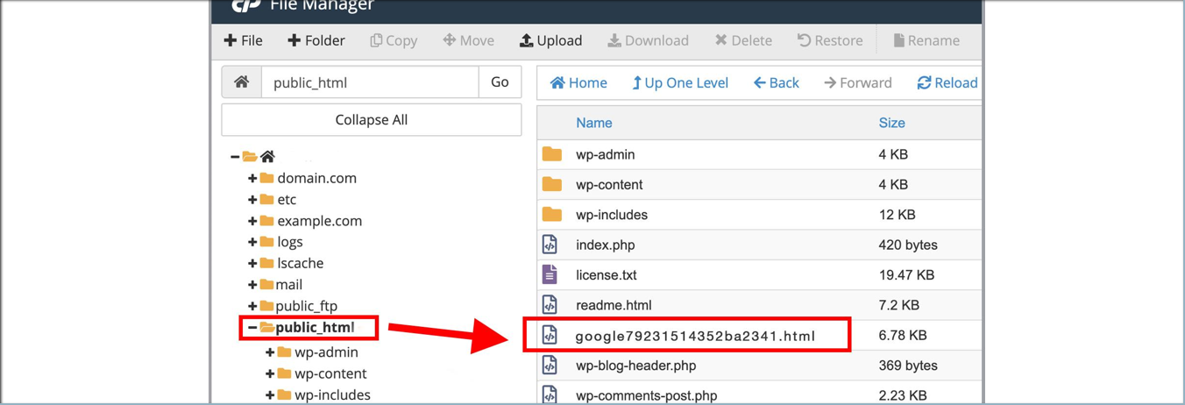

Return to Search Console, and select “Verify”.

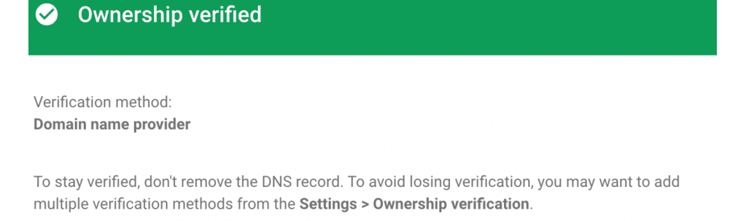The benefits of SEO: (benifits, 2021)

**1- Increases the Appearance of your site and increases the number of visitors who enter the site.**

**2- It provides a great return on investment for sites that sell products.**

**3- Make the websites credible and trustworthy between customers and website owners.**

**4-Provides promotional offers 24 hours a day, seven days a week.**

**5- Improves user experience.**

**6- Enhances the success of the website (PCC).**

**7- A long-term marketing strategy.**

**Five ways to improve your site is ranking (SEO):** (SEO, 2021)

**1- Publish Related Approved Content. For example:** **Identify keyword phrase, content is most influential on search engine rankings.**

**2- Update your content regularly. For example:** **Blogging writing additional content, rich with keyword phrases, and a news blog can also boost your search engine rankings.**

**3- Metadata. For example:** **Title Metadata** **the titles of the pages are displayed at the top of the browser window and as a heading within the search engine results, Description.**

**4- Have a link-worthy site.** **A content-rich, reliable, and unbiased web page and helps visitors learn more about what they are interested in links from other websites, improving search engine optimization.**

**5- Use alt tags.** **Must describe your photo and video with alt tags or alt text descriptions.**

# 10- Evaluate a range of tools and techniques available to design and develop a custom-built website.

|  |  |  |
| --- | --- | --- |
| Compare | Tools | **Custom-built** |
| Definition | They are programs or online services that are used to create websites without the need to learn programming.(tools, 2021) | They are sites that are designed by writing the code and this is done from the beginning and requires a number of skilled and reliable people or one person to create the site that represents brand. (custom-built, 2021) |
| Advantages | 1- Does not require coding skills: does not require learning the basics of programming.  2- Cheap and fast: the site is set up quickly and does not cost large sums of money.  3- Easy to export: The site can be uploaded via many platforms.  4- No design skills required: Websites should look great and attract visitors.  5- It does not require much time: because it is created using ready-made templates.  6- Drag and drop design: You can choose the images and texts and drag and place them where you want. (advantages tools, 2021) | 1- A site that is uniquely designed and represents the brand and depends on your needs.  2- You can make test the site.  3- Will be compatible with search engines.  4- You can also add and modify new items  5- There is no restriction in the use of jobs.  6- It works on all devices.  7- It is safer.  8- High quality.  9- More effective for users.  (advatages custom-bulit, 2021) |
| Disadvantages | 1- Not suitable for professional work.  2- Limited mobile experience.  3- Low search engine ranking.  4- It is similar to other websites that use the same templates.  5-Large page load time.  6- Limited number of features.  7- Limited functions.  8- Easy to hack for hackers.  9. The privacy and security of users are at risk.  10- Attracts viruses and spam easily.  (disadvantages, 2021) | 1- High cost.  2- It takes a long time to create or modify your site.  3- Needs maintenance every now and then.  4- It takes time to develop.  (disadvantages custom-bulit, 2021) |

1-Tools: (tools, 2021)

A. WordPress: It is a website that provides services for creating websites on the Internet. It is easy to use, combines flexibility and power, contains many features, beautiful templates, and creates websites in less time. Not secure data and Frequent Updates

B. Bootstrap: It is a site created by web programmers that provides assistance to programmers in creating a website with less time and effort. It is a framework and it is a library that contains ready-made programming languages ​​such as HTML, CSS, etc. It provides an explanation of the written code and many more. Of abbreviations. And but there are some personal risks and slow growth.

C. Wix: It is an easy-to-use site that provides free and paid services to create different sites and contains many features, including choosing the template you want for the site and images, dragging and dropping inside the site, and providing hosting for the site as well. It contains many proposed models to facilitate site creation and save time and effort.

2-Techniques:

A. PHP (Hypertext Preprocessor): It is a programming language for developing websites and is characterized by being open source and free of any cost, and it is used easily and can be downloaded on all systems such as windows and Linux, etc. It connects to the database and helps to manage the code. It is flexible and integrates with many other programming languages not that secure and poor quality of error handling and fewer debugging tools. (php, 2021)

B. HTML (**Hypertext markup language**): It is a programming language that contains many tags such as tables and lists. It is widely used. Any website should have html. It is also easy to learn and use. It can be downloaded quickly because it is lightweight and useful for beginners who want to learn the language. It is not well safe. If you want to write a long code, you will It produces complex things and is also a stable language. If there are many errors in the code, it will become difficult to solve them. (html, 2021)

C. CSS (**Cascading Style Sheets**): It is a language for designing a website and how to communicate with the HTML language and display documents in a format. It also organizes pages, colors and fonts. It speeds up the site. It is less complex than other languages, reduces effort, is easy to use, and reduces the size of files that are transferred. Some things are not supported. Problems may occur when Opening html file in browsers confusion. (css, 2021)

3-Custom-built:

A. Visual Studio Code: It is a text editor that supports debugging and code. It contains many programming languages, as well as supports windows, mac, and Linux operating systems. It improves the code and the lightweight serial structure. It is free. You need to install some features and it is very difficult to find these features. (vsc, 2021)

B. NetBeans: It is a free development environment that contains many different programming languages ​​and many features. It is also downloaded on many systems such as windows and Linux. It corrects programming errors. It features a visual debugger and is also easy to use.(netbense, 2021)

# 11- Compare and contrast the multipage website created to the design document.

|  |  |  |
| --- | --- | --- |
| **Compare** | **Multipage website** | **Design document** |
| Identifying | It is a set of web pages that can be accessed by domain name and these pages can be published on a web server and these pages are created by an individual, group or organization. Website pages are frequently accessed through a URL. The colors used on the website are all colors. | It is a set of documents that contain all aspects of the site's design and must contain the site's components and basic details, and the design should be in black and white color.  (design doc, 2021) |
| Programing Languages | The sites consist of a front and a backend and the languages ​​are HTML, CSS, JavaScript, PHP, Python, MySQL, Java, etc. | Do not use any programming language in designing the document, but rather use Word, PowerPoint, etc. |

 ***website***

***Design document***

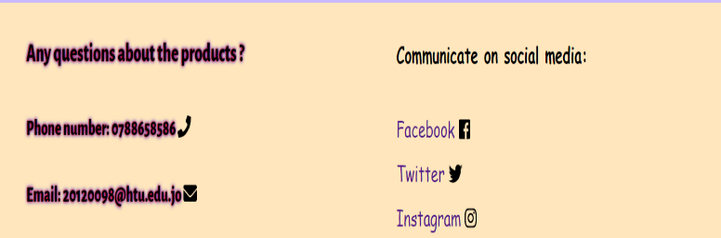

# 12- Evaluate the Quality Assurance (QA) process and review how it was implemented during your design and development stages.

Quality Assurance: It is a procedure to ensure the quality of the site, improve it and ensure that it is fully functional, and works to increase trust between customers and ensure its efficiency. (QA, 2021)

QA Process step: (QA process, 2021)

1- **Plan:** **The plan must be defined, goals and processes required to deliver a high-quality product.**

2- **Do:** **Identified processes will be tested.**

3- **Check:** **Processes will be monitored, modified and verified as meeting objectives.**

4- **Act:** **Actions will be taken to verify the improvements that have occurred.**

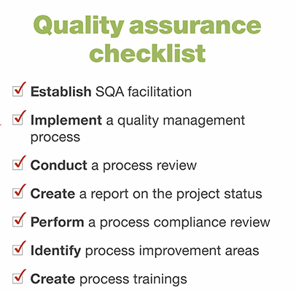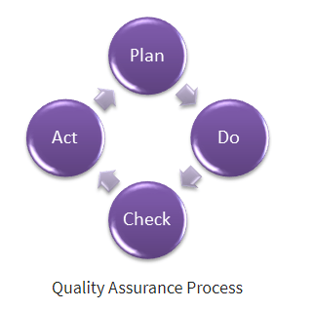

# 13- Justify the tools and techniques chosen to realize a custom built.

Always when designing any web page, whether it is difficult or simple, you must have a comprehensive knowledge of what you need to do, how and the type of materials and that the site includes a front and back interface, user requirements and design, so you can use many techniques, tools and custom-built sites.

1. Tools: They are templates that are used to create easy and fast websites that allow you to develop your website without having to learn how to code and do not need special skills and do not take time to create it. It is not suitable for students who want to learn programming and it is harmful to them and therefore I did not use any of them and not take advantage of it.
2. Techniques: They are techniques used to develop websites and they consist of two technologies, the front-end technology and the back-end technology, which are many programming languages, including HTML, CSS, PHP, JavaScript, MySQL these techniques I used to create my site are very useful for beginners. For example techniques: 1-Responsive Design.
3. Custom builds: They are sites that are designed by writing code and this is done from the beginning and requires a number of skilled and reliable people or one person to create the site that represents the brand. It is useful for people who want to learn and who want to design websites from start to finish and learn from their mistakes and this is the method I used to create my site. (custom-built, 2021)

(tools, techniques, custom, 2021)

# 14- Critically evaluate the design and development process against your design document and analyse any technical challenges.

Design development: It is a stage in which all the features that will be present in the design and the layout of the pages that will be created are determined.

Web development challenges during planning: (web chalngs planing, 2021)

1- Clearly defining your goals: When goals and requirements are defined, you can address many of the processes such as performance and velocity during the planning stage.

2-Choosing the right tech stack: When you mix frameworks, other tools, and software techniques for building the website, a stack must be chosen to match the problems that help you improve scalability.

3- User experience: Upon completion of the site design and writing the code, the site must be tested to find out things that the user may not like, so it is simplified and facilitated to make the user feel satisfied.

4- User Interface and simplistic design: The interface of the site should be perfect because it attracts users to the site and makes it simple for users.

5- Performance and speed: The performance of the site must be very high and fast, because if the site is slow, the user will not wait and will leave the site and it will affect the site's reputation.

6- Scalability: The site must remain developed and planning helps to make the site expandable because it improves the user experience and achieves the goals.

7- Web security threats: The site must be secure, save user data, and ensure the infrastructure is secure.

I encountered difficulty in designing my site at the beginning of designing the first page. I thought for an hour what the site would look like, and then when designing the first page after modifying it many times, then after that I found it easier to design other pages because I had no experience in designing sites it benefited a lot, as it was the first experience.

# 15- Critically evaluate the results of your Test Plan and include a review of the overall success of your multipage website; use this evaluation to explain any areas of success and provide justified recommendations for areas that require improvement.

|  |  |
| --- | --- |
| Review test plan | success |
| 1- Ensure that all pages are working. | I checked all the pages I had and made sure they were working. (Pass) |
| 2- Ensure that all links are working. | I checked all the links I had and made sure they worked. (Pass) |
| 3- Ensure that the data that is called is stored in the database. | I made sure that the stored data is working and that when I add new information it is added. (Pass) |

When the required goals are determined, the review becomes easy. I reviewed the test plan twice and modified the plan to suit my site and made sure of the results after I tested them. I conducted the process of reviewing the results and making sure that they were suitable for my site. I identified the expected results with the test results and were compatible and appropriate for the site and the requirements. Extensive testing processes to verify that the site is working properly I will improve my site by setting an ideal test plan that fits all pages of my site and I will improve the password entered to make the password consist of 8 characters, signs and numbers This step will help improve the security of the site

# Domain and Hosting steps:

A. Domain steps:

1- Find a GoDaddy website to buy a domain. Then click on the link to enter the site.

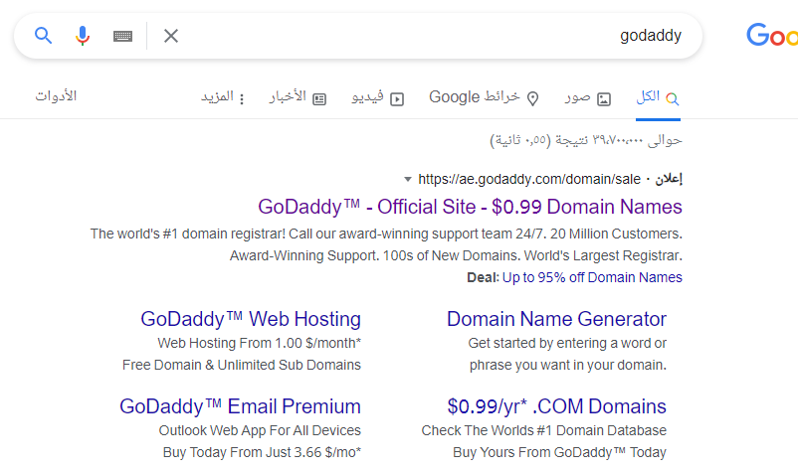

2-The home page of the site appears when text box (Find your perfect domain) write the name of the domain you want to buy then press Enter.

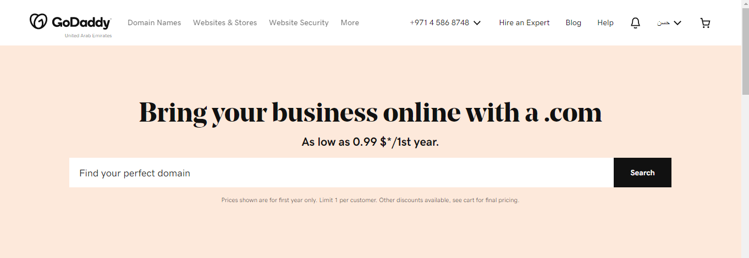

3-Then, the name of the available domains that can be purchased will appear to you, and then click on Add to Card.

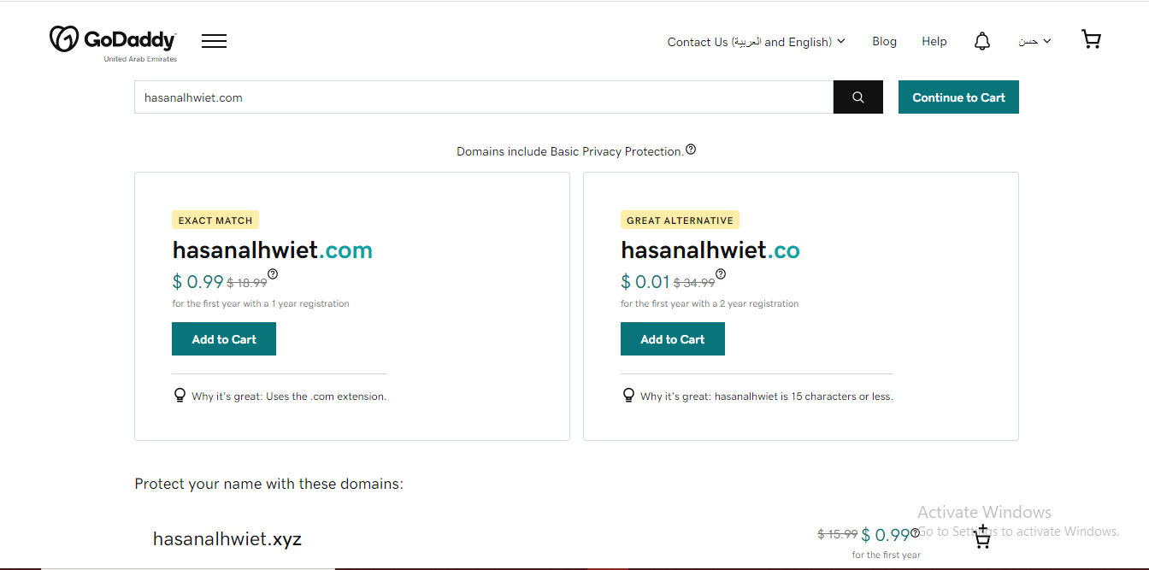

4-Next, next to the page, you will see the domain name and its price, click (Looks Good, Keep Going).

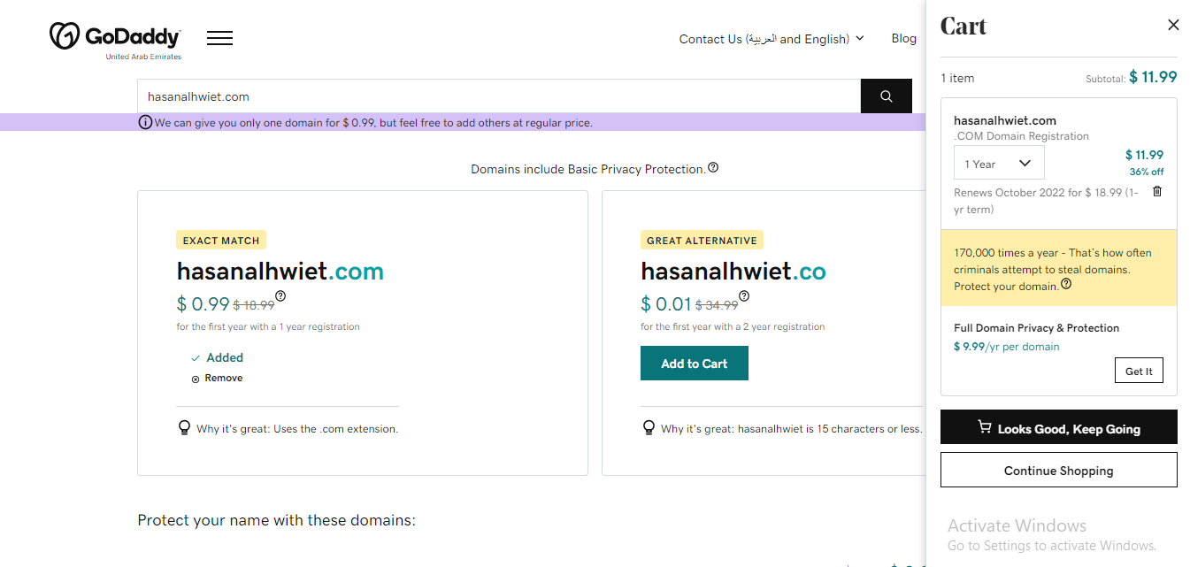

5-After that, the total price for the domain name and any additions you want appears, then after completing that, click on (I'm Ready to Pay)

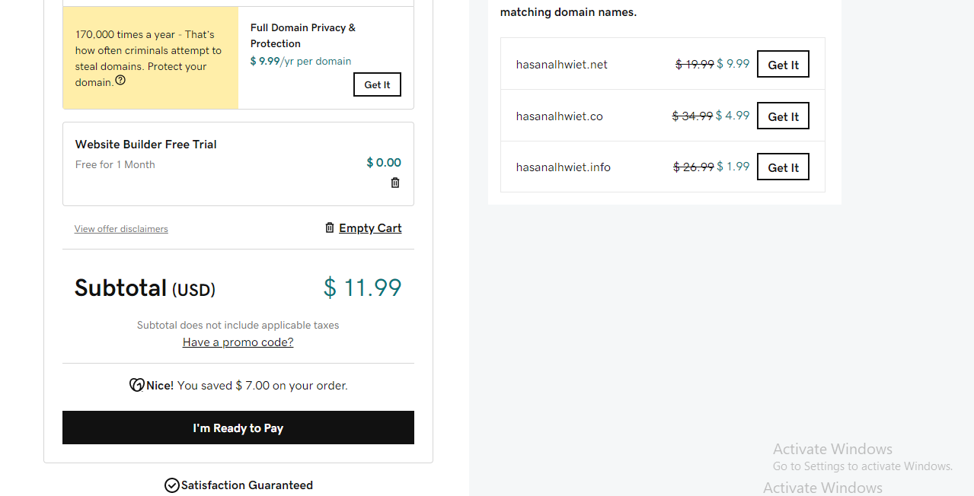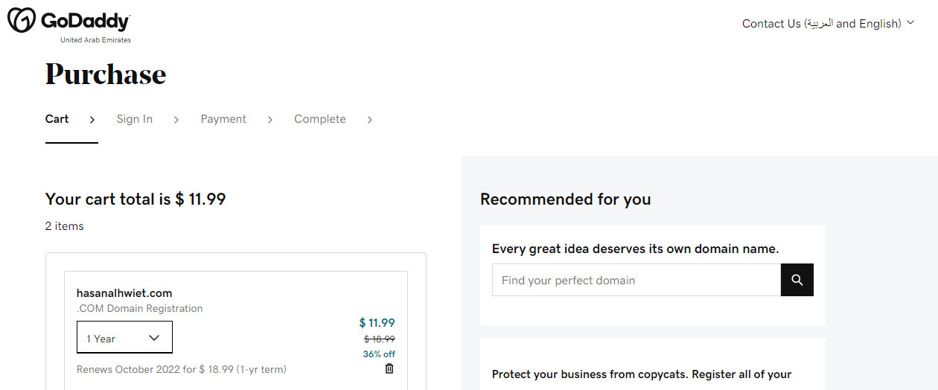

6-Fill in the required data in order to purchase a domain name.

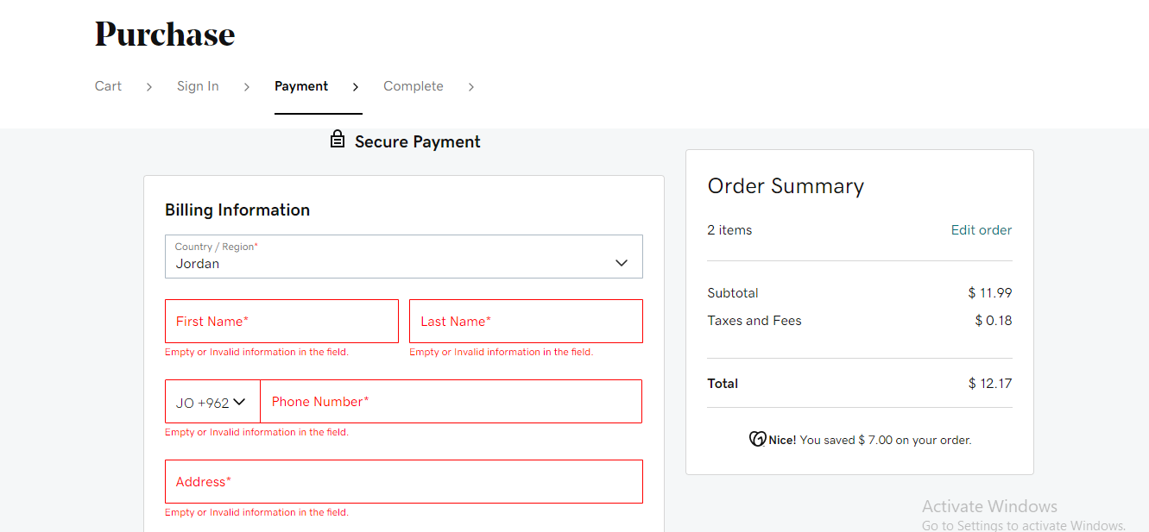

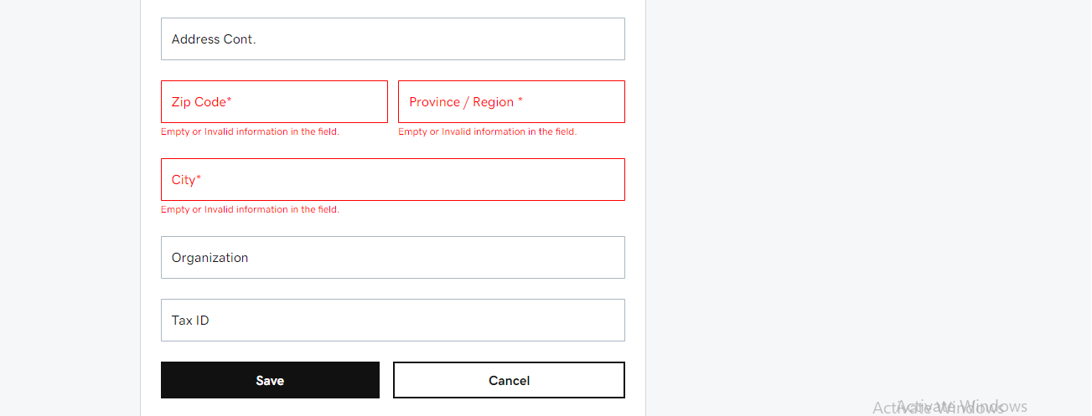

7-Enter the card information to purchase the domain name then click on (Complete Purchase).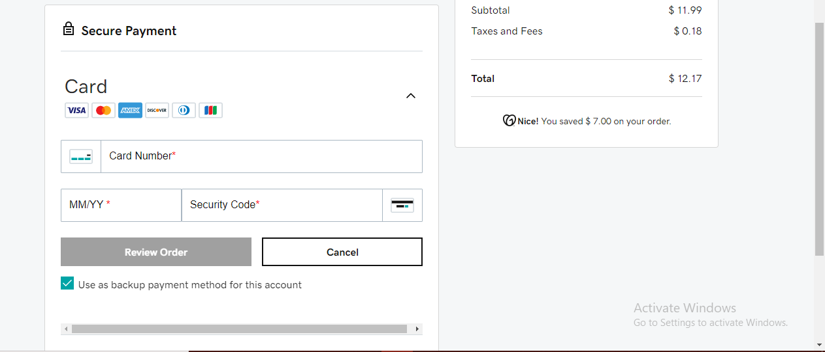

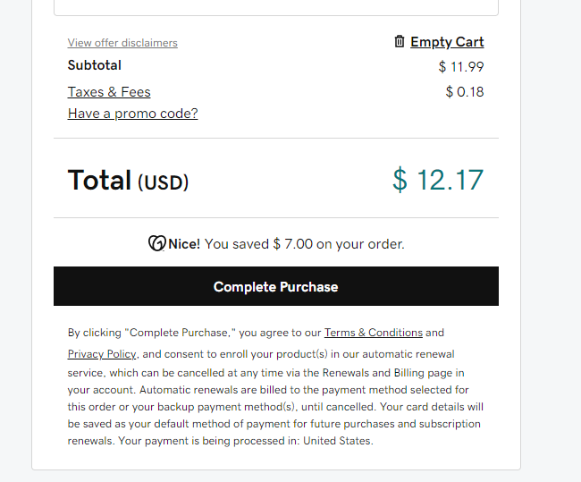

B. Hosting steps:

1- Find a Free Hosting website to buy hosting. Then click on the link to enter the site.

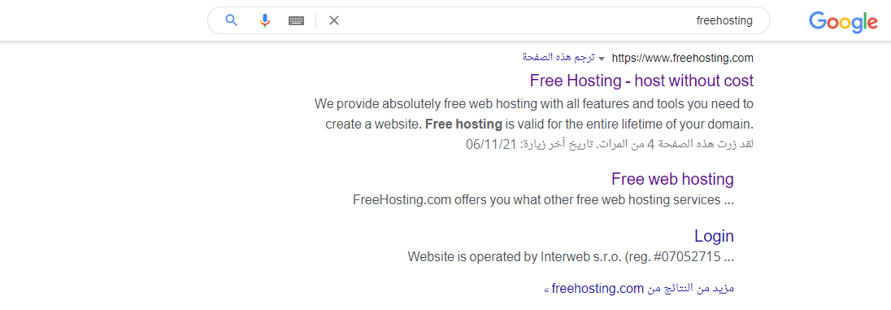

2-The homepage of the site appears Scroll down.

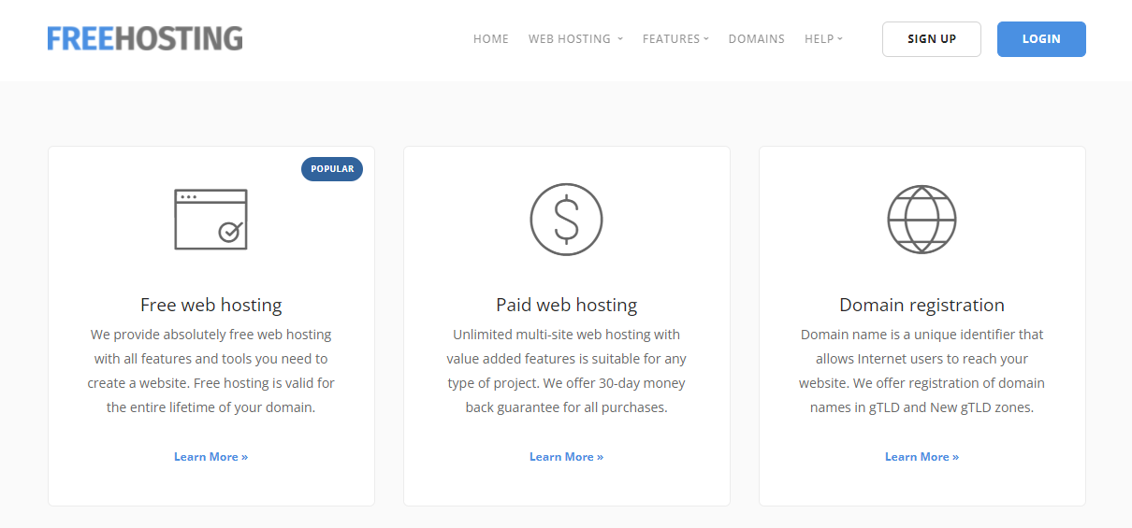

3-Stand here and click on a free hosting package

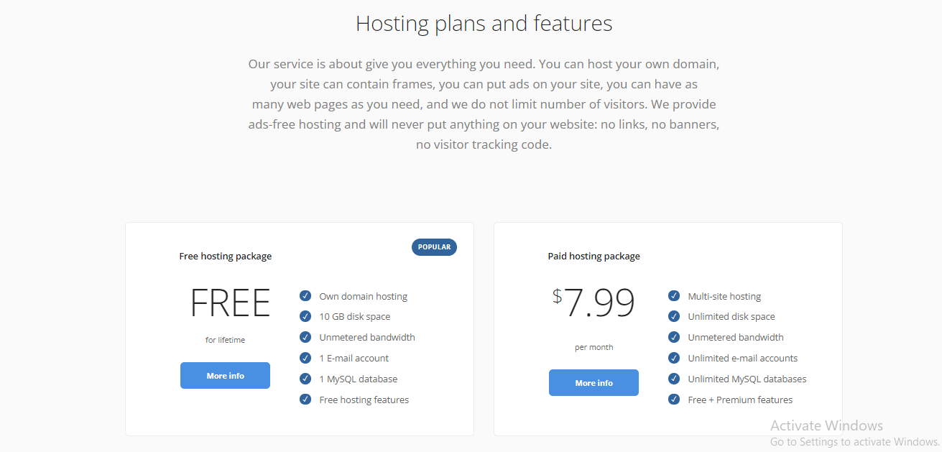

4-When this page appears, click (sign up for free).

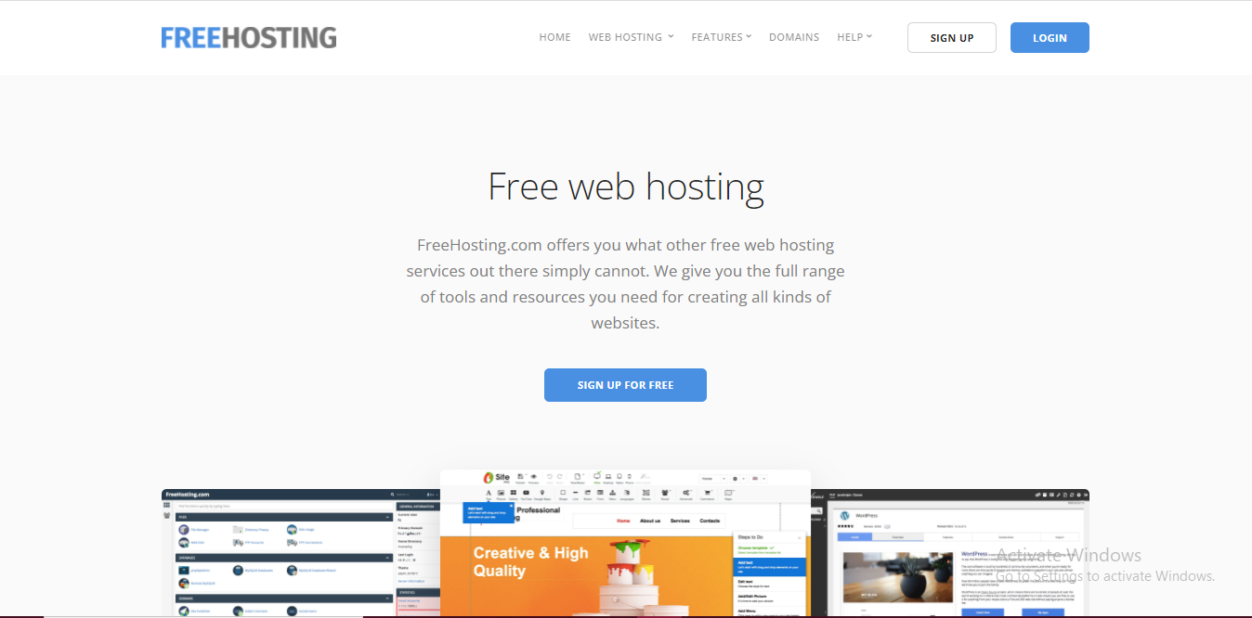

5- Fill in the required data in order to purchase a domain name.

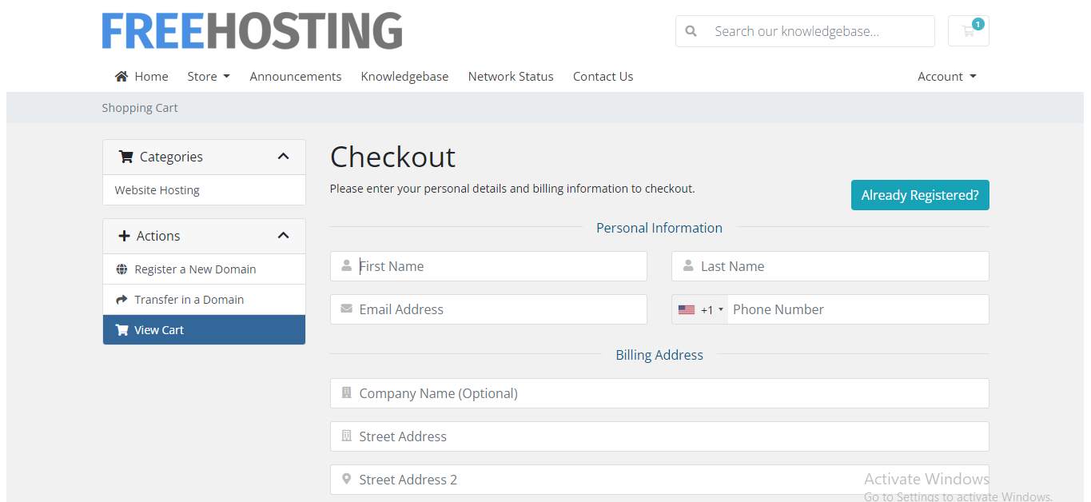

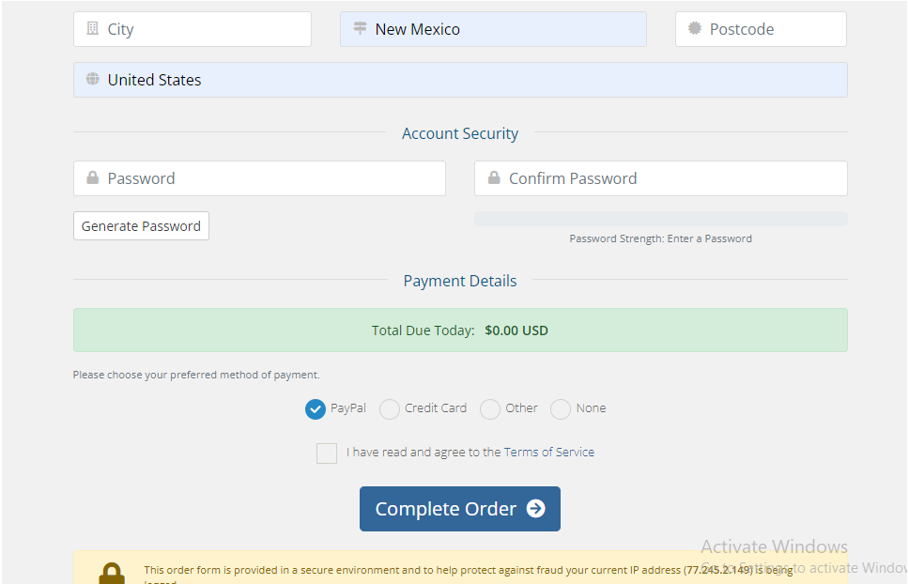

6-After creating an account, it will send you to this page, choose the third option, type your domain name, and click Use

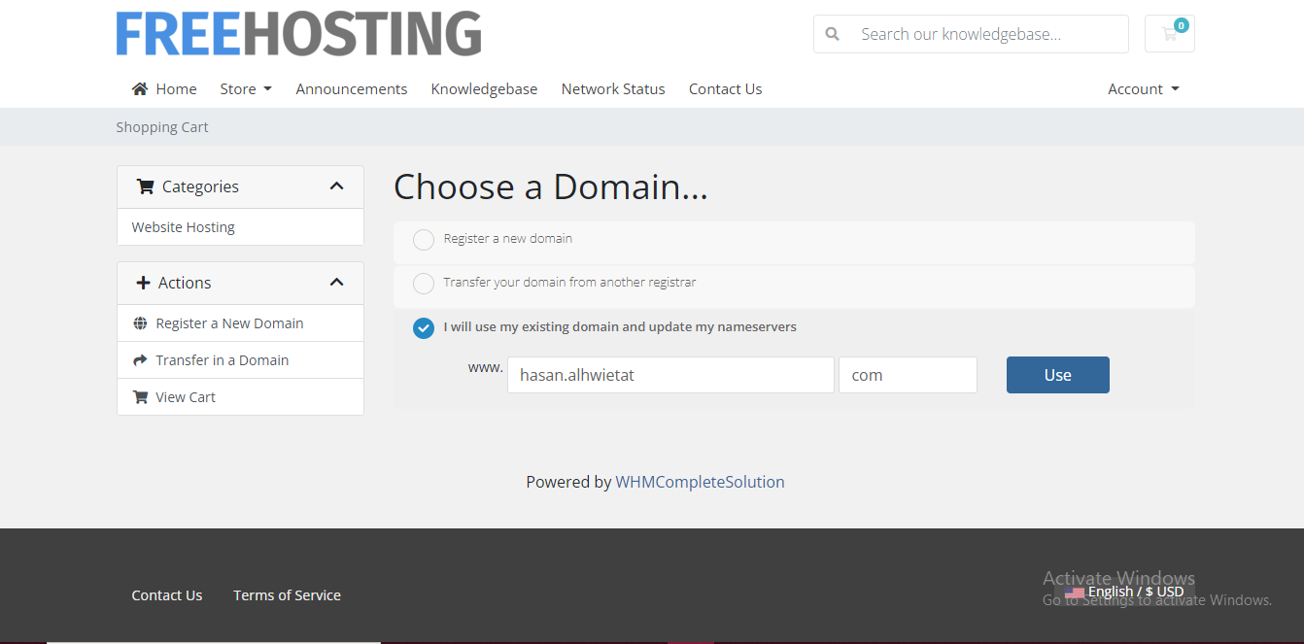

7-When this page appears showing information about the host you want to buy, click Continue.

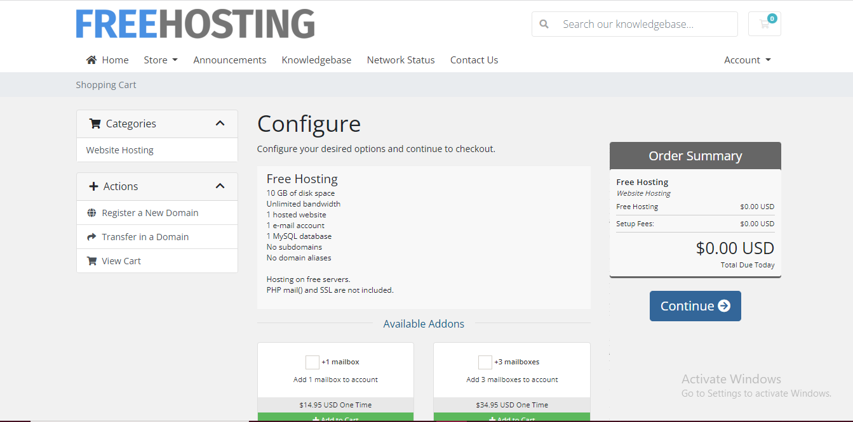8-When this page appears to confirm your purchase, click Continue.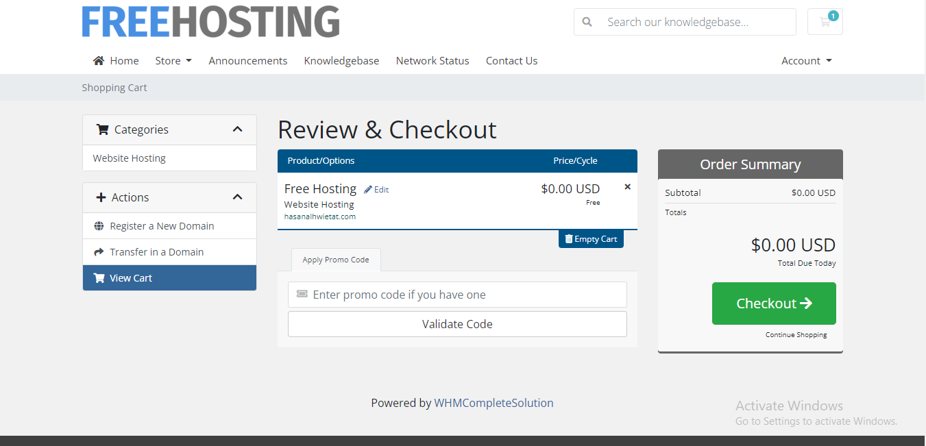9- Hosting has been created for your domain.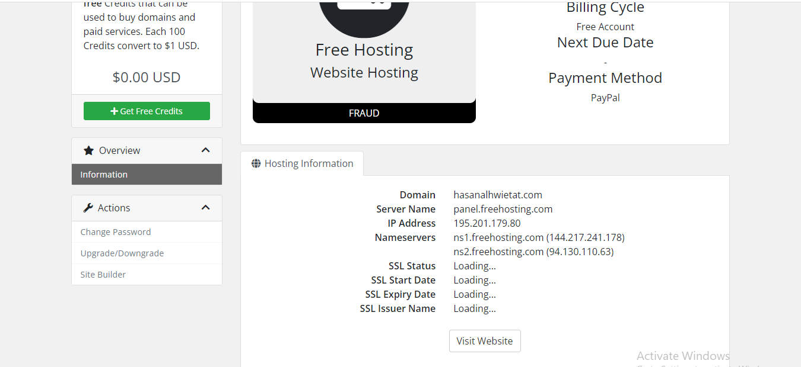

C. Steps to associate a domain with hosting:

1- Make a copy of the name server and put it in the domain location.

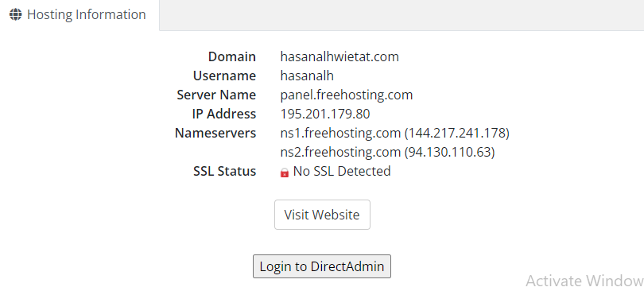

2- Go to the domain's website and go to DNS Management, then scroll down.

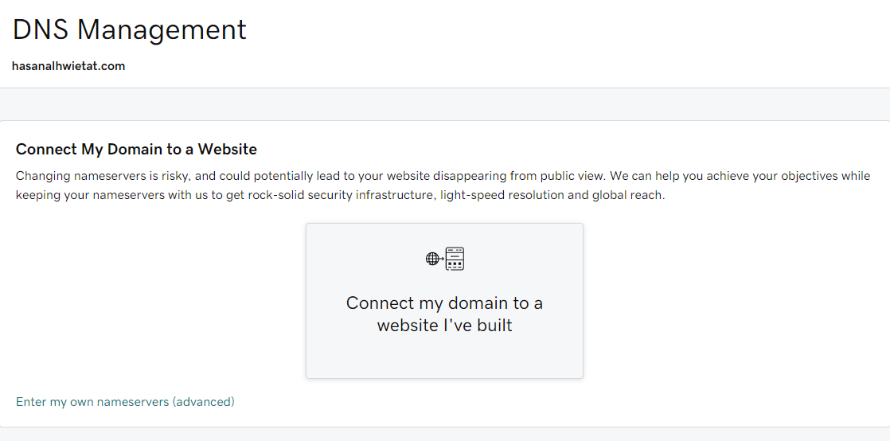

3- Then stop here and click Change.

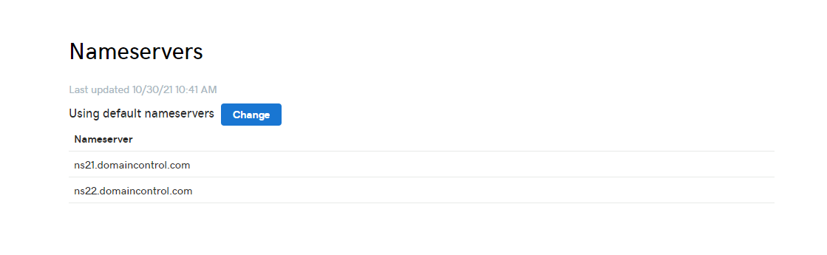

4- Put the name servers that you copied from the hosting site and put them here, then click Save.

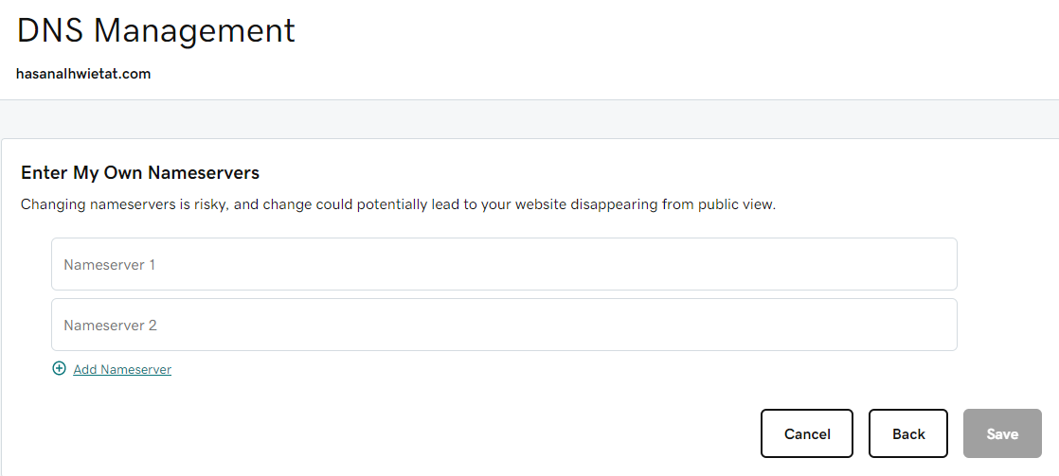

5- After changing the name servers, click Yes and then click Continue.

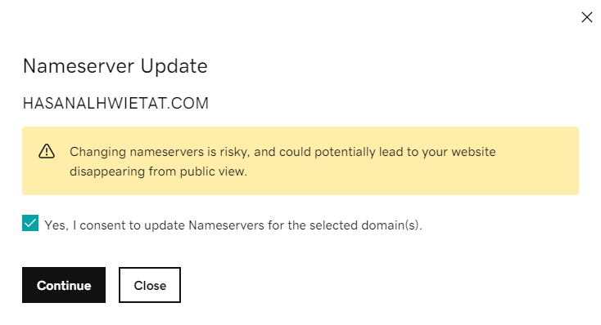

6- The name servers have been changed successfully.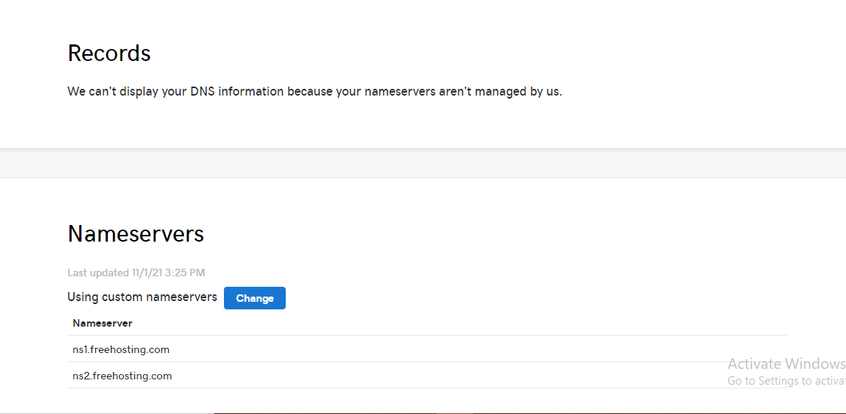

7- When you search for your domain name on Google, this page will appear. You have a website and hosting as well. You have to build this page.

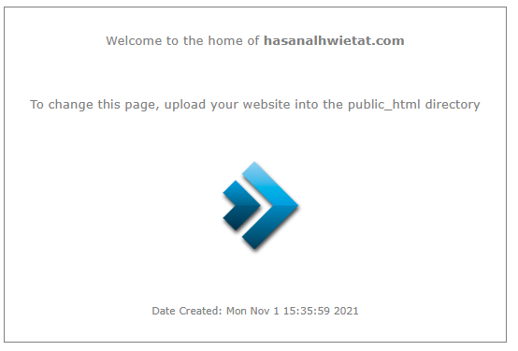

# Publish you website:

1- First, I will go to the site I chose to host my site and then log in to my account.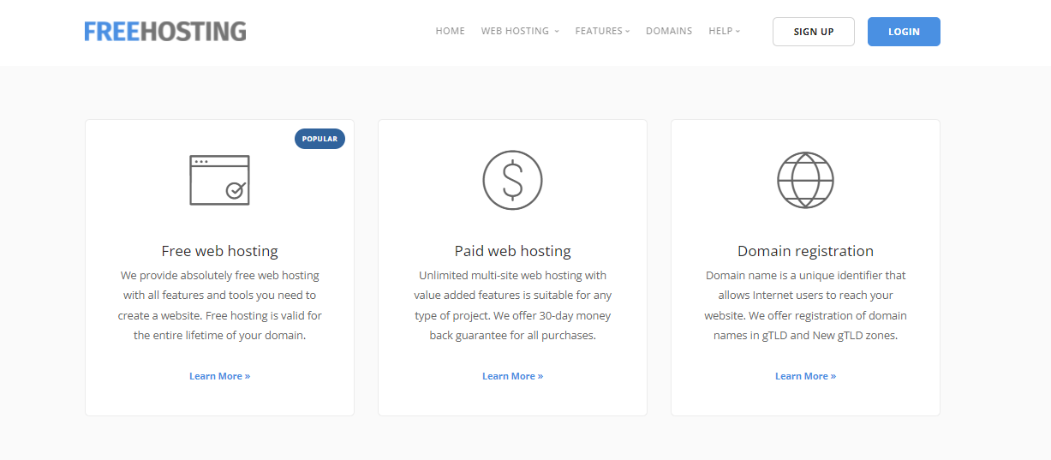

2- After logging in, this picture will appear to me, I click on the servers.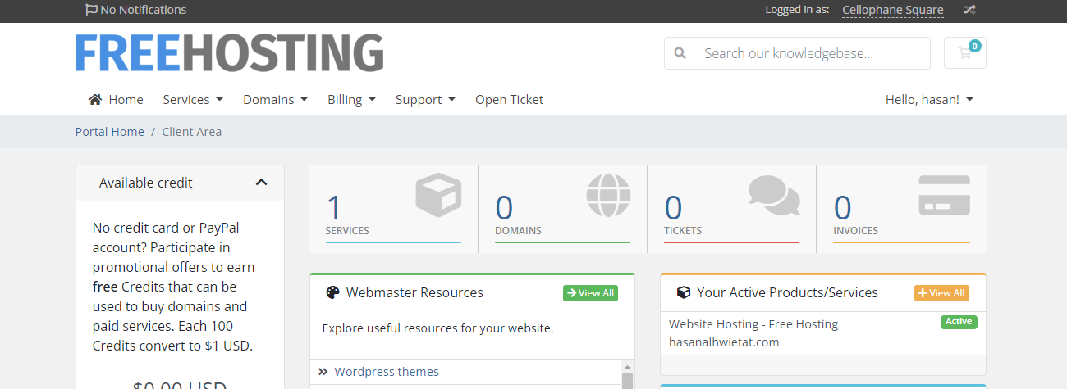

3- This page will appear and I will scroll down and click on Login to DirectAdmin.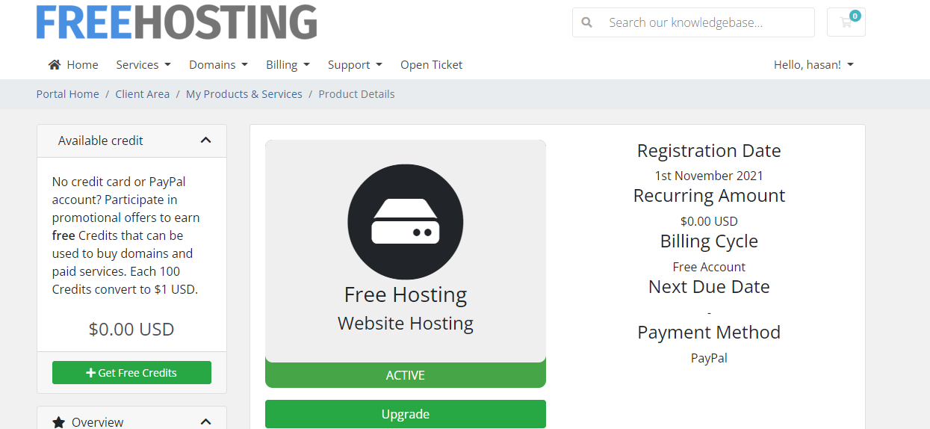 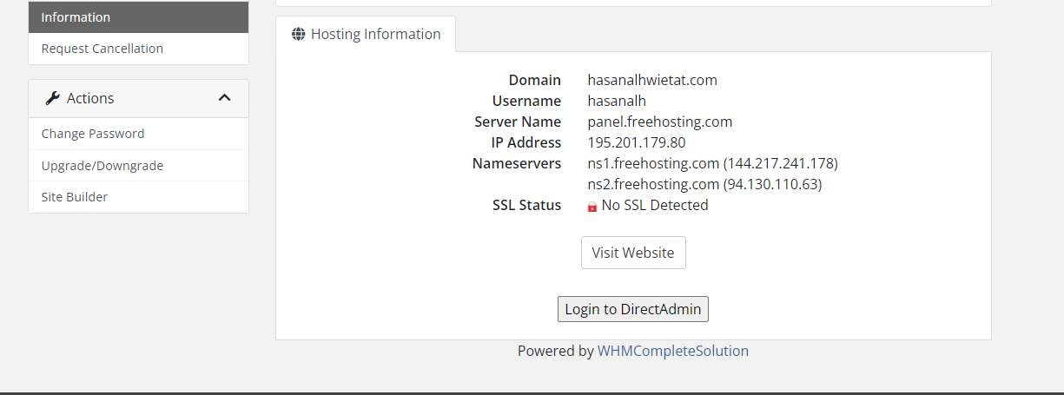

4- This page will appear. I will click on the menu, then click on System info & Files, then click on File Manager.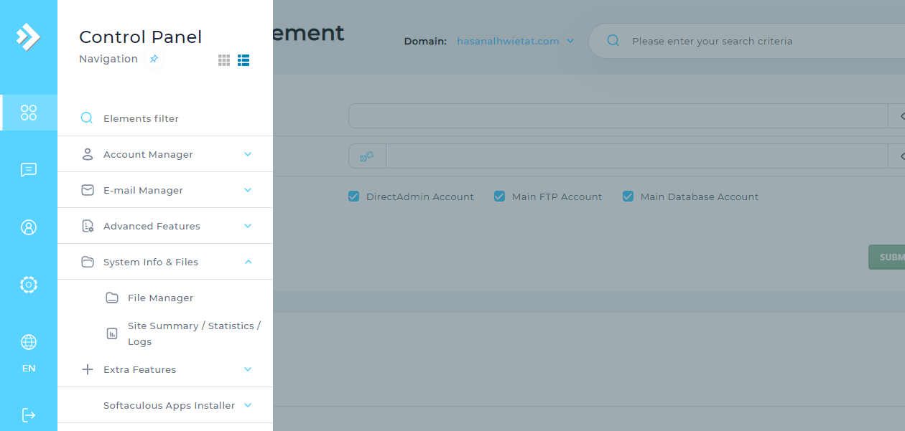

5- After the previous step, this screen will appear. I will click on Public_html and download all the html, CSS, PHP files, database.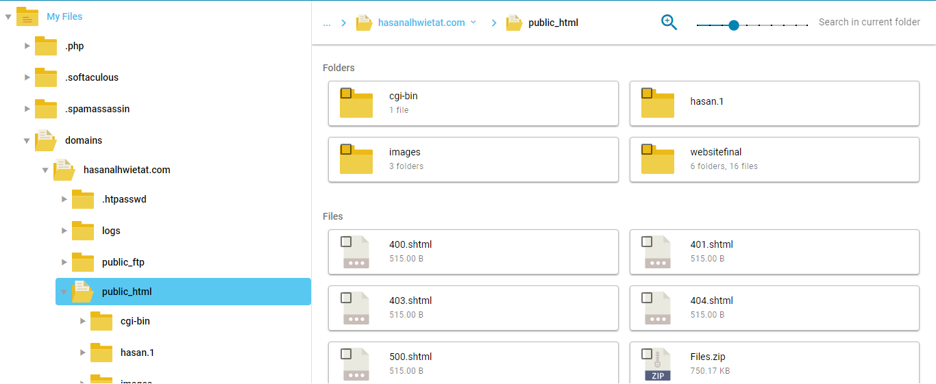

6- Then I will go to the site by putting the domain name inside the URL.